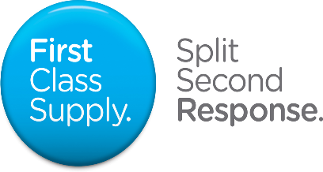

Secondary School Teacher

A secondary school teacher teaches one or more national curriculum subjects to pupils aged 11-16, or up to 19 in schools with sixth forms.
Teachers plan lessons in line with national objectives to ensure that pupils learn. They also encourage, monitor and record the progress of their pupils.
Teachers support, observe and record the progress of their class. They also plan lessons in line with national objectives with the aim of ensuring a healthy culture of learning.
Teachers must also keep up to date with developments in their subject area, new resources, methods and national objectives. Teachers liaise and network with other professionals, parents and carers both informally and formally.

Typical work activities
Typical work activities include:
- preparing and delivering lessons to a range of classes including putting up displays in the classroom;
- marking work, giving appropriate feedback and maintaining records of pupils' progress and development;
- researching new topic areas, maintaining up-to-date subject knowledge and then devising and writing new curriculum materials;
- selecting and using a range of different learning resources and equipment, including podcasts and interactive whiteboards;
- undertaking pastoral duties, such as taking on the role of form tutor, and supporting pupils on an individual basis through academic or personal difficulties;
- preparing pupils for qualifications and external examinations;
- managing pupil behaviour in the classroom and on school premises, and applying appropriate and effective measures in cases of misbehaviour;
- supervising and supporting the work of teaching assistants, trainee teachers and newly qualified teachers (NQTs);
- participating in and organising extracurricular activities, such as outings, social activities and sporting events;
- participating in departmental meetings, parents' evenings and whole school training events;
- liaising with other professionals, such as learning mentors, careers advisers, educational psychologists and education welfare officers;
- undergoing regular observations and participating in regular in-service training (INSET) as part of continuing professional development (CPD);
- teaching in middle schools, which take children aged eight or nine to 12 or 13, teaching the primary or secondary curriculum appropriate to the age of the children.

First Class Supply are a genuine independent Employment Business that specialises in the education sector. We have an unrivalled, fantastic reputation for delivering an exceptional, personal service to our partner schools, teachers and support staff alike.

We have forged strong partnerships with schools in Northumberland, North Tyneside, Newcastle, Gateshead, South Tyneside, Sunderland, Durham and Tees Valley.

If you would like to learn more about us and join the largest independent supply teaching agency in the North East visit our website; www.firstclasssupply.co.uk Alternatively, contact us on 0191 251 5566 to speak to one of our friendly team.

