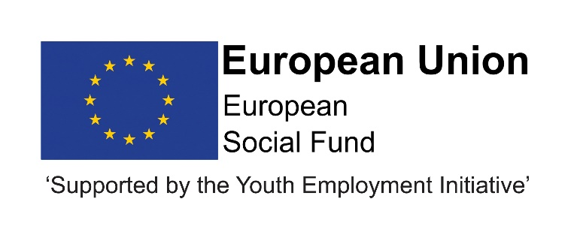

JOB DESCRIPTION

Children and Young People’s Services

 | POST TITLE: | Business Apprentice
 | POST NUMBER:
 | GRADE: | Apprentice
 | LOCATION: | Your normal place of work will be Crook Civic Centre. However, you may be required to work at any council workplace within County Durham.

- RELEVANT TO THIS POST:
This post is funded until July 2021 through the ESF/YEI DurhamWorks project.

This post is funded through ESF and the Youth Employment Initiative (YEI) as part of the 2014-2020 European Structural and Investment Funds Growth Programme in England. The YEI/ESF funding will end in July 2021.

Flexible Working: Subject to service needs, the Council’s flexible working policy is applicable to this post.

- ORGANISATIONAL RELATIONSHIPS:

The post holder will be accountable to the Administration Coordinator and will be supported and mentored to develop in the role by the team. The Apprentice will establish good working relationships with a range of internal and external colleagues and partners.

- DESCRIPTION OF ROLE:
To develop skills to provide administrative support to all staff within the team so that the ESF programme operates effectively and efficiently.

- DUTIES AND RESPONSIBILITIES SPECIFIC TO THIS POST:
Listed below are the responsibilities this role will be primarily responsible for.
To build up the necessary skills to support the team and work proactively to support the team and service delivery by:
- receiving visitors and referring to appropriate colleagues
- answering telephones and recording messages
- word processing, production of reports and preparation of presentation slides
- updating and maintaining databases and filing systems and photocopying
- despatching and receiving/opening post and other material and ensuring prompt despatch to appropriate staff
- ensuring appropriate support for, and the health and safety of, visitors
- working within current Data Protection requirements, Information Sharing protocols and Caldicott Guidelines.

All employees have a responsibility to undertake training and development as required. They also have a responsibility to assist, where appropriate and necessary, with the training and development of fellow employees.

All employees have a responsibility of care for their own and others health and safety.

The above is not exhaustive and the post holder will be expected to undertake any duties which may reasonably fall within the level of responsibility and the competence of the post as required by the Service.

Variation may also occur to the duties and responsibilities without changing the general character of the post.

9. COMMON DUTIES AND RESPONSIBILITIES:

9.1 Quality Assurance
To set, monitor and evaluate standards at individual, team performance and service quality so that the user and the Service’s requirements are met and that the highest standards are maintained.

To establish and monitor appropriate procedures to ensure that quality data are reported and used in decision making processes, and to demonstrate through behaviour and actions a firm commitment to data security and confidentiality as appropriate.

9.2 Communication

To establish and manage the team communications systems ensuring that the Service’s procedures, policies, strategies and objectives are effectively communicated to all team members.

9.3 Professional Practice

To ensure that professional practice in the team is carried out to the highest standards and developed in line with the Service’s stated objectives of continual improvement in quality of its service to internal and external customers.

9.4 Health and Safety

To ensure that the Health and Safety policy, organisation arrangements and procedures as they related to areas, activities and personnel under your control are understood, implemented and monitored.

9.5 Appraisal

All members of staff will receive appraisals and it is the responsibility of each member of staff to follow guidance on the appraisal process.

9.6 Equality and Diversity
As an organisation we are committed to promoting a just society that gives everyone an equal chance to learn, work and live free from discrimination and prejudice. To ensure our commitment is put into practice we are developing policies, which will seek to remove any barriers to equality of opportunity and to eliminate unfair and unlawful discrimination.

These policies apply to all employees of Durham County Council.

9.7 Confidentiality

All members of staff are required to undertake that they will not divulge to anyone personal and/or confidential information to which they may have access during the course of their work.
All members of staff must be aware that they have explicit responsibility for the confidentiality and security of information received and imported in the course of work and using Council information assets. The Council has a Personal Information Security Policy in place.

9.8 Induction

The Council has in place an induction programme designed to help new employees to become effective in their roles and to find their way in the organisation.

Person Specification: Apprentice
 | Essential | Desirable | Method of Assessment
Qualification | - Hold or have the ability/willingness to work towards and achieve before the end of the apprenticeship GCSEs in Maths and English (A-C) or equivalent qualifications in the subjects at level 2 |  | - Application form  - Selection Process  - Pre-employment checks
Experience | - Experience of Microsoft Office e.g. Word, Excel etc. | - Experience of dealing with people and/or young people.  - Office administration  - Providing Reception and Clerical support to a range of staff  - Customer Service | - Application form  - Selection Process  - Pre-employment checks
Skills/knowledge | - Good listening and communication skills (written and verbal)  - Good organisation skills | - Work with people.  - Excellent ICT skills using MS Office | - Application form  - Selection Process  - Pre-employment checks
Personal Qualities | - Commitment to service delivery to the highest quality/standards.  - Ability to:  - Work as part of a team  - Use initiative  - Take a flexible approach to work  - Be methodical and pay attention to detail  •Holds high aspirations for young people/young adults |  | - Application form  - Selection Process  - Pre-employment checks

