Durham Trinity School & Sports College
Additional information for the 14-19 secondary specialist ASD teacher vacancy
We have moved in to our new school
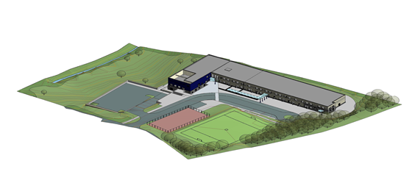
Would you like to teach in this purpose built environment? If so, read on.
The new school building opened after half term in November 2014.
It has brought together the 3 sites of the school in 1 building.
Our new school building accommodates:
- Nursery, KS1 & KS2 classes, all ages of specialist ASD provision, all ages of sensory provision on the ground floor. Each class has direct access to their outdoor learning space.
- Secondary pupils and Post 16 pupils on the first floor. Specialist teaching rooms are located on this floor.
There are 2 dining areas on the ground floor. One is used by primary pupils and the other by secondary pupils. The multi-purpose hall is timetabled for PE lessons throughout school.
The design of the building has embraced the gradient of the site and there is a small lower ground floor area. The small swimming pool is located on this level along with a variety of rooms for professionals, visiting and school based staff.
Externally there will be a MUGA and sports field. The sports field will be operational from April 2016 Flambard school building has been demolished and the grass seed will be sown in the coming weeks. There is also a grassed area for pupil use below the building and car park.
We are a popular school. Currently there are 204 pupils on roll. Over time this will rise to 220.
The school website www.durhamtrinity.durham.sch.uk has further information about different aspects of school life.
Interested candidates are invited to visit school on an informal basis. Please contact the school office (0191 3864612) if you wish to arrange a visit.
About the 14-19 specialist ASD provision teacher post.
This is a new provision on offer from September 2015. As this is a new and growing provision the class is likely, in the first instance to cover a 14-19 age range.
In time it may become a specific Post 16 provision as the numbers increase within this age range.

The classroom environment will be distraction free low stimulus. The class will have 6 pupils and a teaching assistant.

Pupils will access appropriate external accreditation.

