TEACHER OF DESIGN AND TECHNOLOGY
Candidate Information Pack
INTRODUCTION

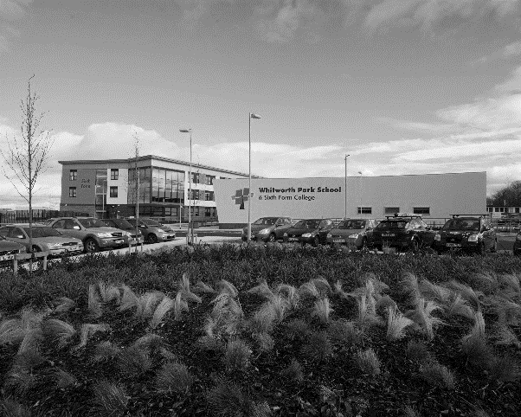
Whitworth Park School and Sixth Form College is a successful, welcoming and caring school.
Whitworth Park was opened in September 2012 following the amalgamation of Spennymoor School and Sixth Form Centre and Tudhoe Grange School. Both schools were highly successful serving the community of Spennymoor and the surrounding villages. The school is situated in a semi-rural location within easy reach of the cities of Durham and Newcastle-Upon-Tyne. Spennymoor is also ideally located for access to the A1M which is situated close by whilst house prices are moderate when compared to the National average.
The school offers a broad and balanced curriculum and is committed to offering the highest quality learning experience to all of its students.

THE DESIGN AND TECHNOLOGY DEPARTMENT

The Design and Technology department is a strong and forward-thinking team. Together, the team creates an outstanding learning environment and embraces innovative teaching strategies to inspire the students.
Presently, the department consists of eight teachers who teach across the ability and age range. Within the department there is an Assistant Subject Leader responsible for a key aspects of attainment and achievement.
The department itself is accommodated in a newly refurbished part of the school where staff have significant teaching space, break-out areas and specialist industry standard equipment. All rooms benefit from an interactive whiteboard that links directly to each teacher’s laptop. There is a DT office at the heart of this department. There is also an ICT suite for the sole use of the department. Two dedicated, full-time Technicians support the work of the department.
JOB DESCRIPTION

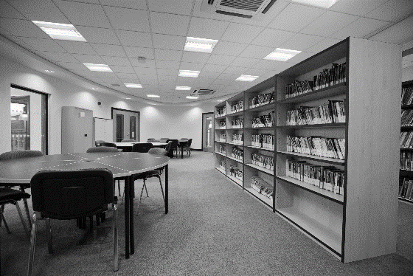
JOB TITLE:
TEACHER OF DESIGN AND TECHNOLOGY
ACCOUNTABLE TO:
SUBJECT LEADER FOR DESIGN AND TECHNOLOGY
GRADE:
MPS/UPS

Whitworth Park School and Sixth Form College is an Equal Opportunities employer. We want to develop more diverse workforce and positively welcome applications from all sections of the community. Applicants with disabilities will be invited for interview if the essential job criteria are met. The school is committed to safeguarding and promoting the welfare of children and young people and expect staff and volunteers to share this commitment. Any offer of employment will be subject to receipt of an enhanced DBS Certificate and Pre-Employment Health Check.

THE ROLE:
This an exciting opportunity to join an already strong Design and Technology team and contribute to the success of the whole school.
We are looking to appoint an outstanding teacher of Design and Technology who is able to inspire young people through their passion for their subject and somebody who is committed to getting the very best outcomes from all their students. An ability to teach across a range of Technology subjects is essential whilst the ability to teach Art would be advantageous. The successful candidate will stretch the most able students as well as motivate and inspire those who do not arrive at Whitworth Park with a natural love for this subject area. We are very fortunate that our intake is truly comprehensive; we receive students with naturally enquiring minds and a keen interest in developing and owning their learning.
The successful candidate would need to be a highly motivated and enthusiastic teacher of Technology. You must be committed to the subject, with high standards and expectations. This role offers the opportunity for an imaginative, creative and inspiring teacher to work in a supportive, energetic and high attaining department.

THE CURRICULUM:
The Design and Technology department aims to inspire, nurture and foster a passion to succeed.
The department offers an extensive curriculum covering Electronics, Engineering, Food Technology, Graphics, Product Design and Textiles across key stages three, four and five.
All students in the school have the opportunity to study Design and Technology and from September 2014 Engineering at key stage three with an option to select from all GCSE DT subjects at key stage four as well as GCSE Engineering. At key stage five students can maintain their studies in Design and Technology. The Department runs two A’ Level Product Design courses, one in 3D products and the other, which is a new course from September 2013, Art and Design, Graphic Communication.
All Y7 students are given the same Design and Technology task when they arrive. This task is based around a common theme used across the majority of curriculum areas and initiated in primary schools. This sets a baseline assessment to identify levels of progress.
Through a carefully planned rotation system key stage three students acquire a broad range of experiences in the subject. The curriculum delivered is engaging and inspires students to achieve excellent results. Students will also have the opportunity to participate in Technology and STEM challenge days, as well as various competitions including F1 in Schools and the inter school Engineering Challenge. As of Sept. 14, the department will offer Engineering at KS3 alongside the existing DT cycle.
DT and Engineering at Whitworth Park uses modern manufacturing processes such as CAD/CAM and works with traditional and modern materials. It’s an exciting, relevant, rigorous and challenging 21st century subject – It is successful and is very popular at GCSE level.
The department is forward thinking and has embraced new developments in teaching and learning. It is recognised as a ‘lead department’ in the school, and is highly regarded at County level. The department has also represented the school in County wide teaching and learning initiatives.
Overall effectiveness is strong due to a team of specialists, varying in backgrounds and experience.

KEY RESPONSIBILITIES
Staff are expected to support and contribute to the school ethos.

Success through Partnership- an inclusive education for all learners in the community of Spennymoor providing
“Excellence for Everyone.”

The school will create an environment which is inspirational and aspirational, in which every learner has the opportunity to develop the skills to lead a positive and fulfilling life. We will work in collaboration with parents, carers, the community, and all other educational and service providers to nurture all of our young people. Our educational programme will provide a climate which inspires learning, creates trust, respect and tolerance and promotes sustainability and collaboration - “Excellence for Everyone”.

General Expectations

Staff will:
• contribute effectively to the work of the school and to the achievement of the ‘School Improvement
Priorities’;
• play a full part in the life of the school community, to support our distinctive aims and ethos, to
encourage staff and students to follow this example;
• follow school policy regarding care, support and supervision of students;
• attend training and development activities and courses, ensuring continuing, personal and
professional development;
• contribute to a welcoming school culture by promoting mutual respect for all;
• comply with any reasonable request from a leader to undertake work of a similar level that is not
specified in this job description;
• work as a team member;
• act as a role model to students in speech, dress, behaviour and attitude;
• have common duties in the areas of: Quality Assurance, Communication, Professional Practice,
Health & Safety, General Management (where applicable), Financial Management (where
applicable), Appraisal, Equality & Diversity, Confidentiality and Induction.

This job description will be reviewed annually and may be subject to amendment or modification at any time after consultation with the post-holder. It is not a comprehensive statement of procedure and tasks but sets the main expectations of the school in relation to the post holder’s professional responsibilities and duties.

Whitworth Park School and Sixth Form College is committed to safeguarding and promoting the welfare of children and expects all staff and volunteers to share this commitment. This post is subject to signing our ICT Staff User Policy and having a satisfactory Enhanced DBS Certificate.

Duties and Responsibilities for all Teaching Staff

All teaching staff will:
• work within the National Conditions for Employment of School Teachers (STPCD);
• uphold and observe the Professional Code for Teachers (GTC) and meet the National Standards for
Qualified Teachers;
• support and encourage colleagues at all levels within the school;
• promote the school’s stated ethos and support the school’s policies in student leadership and
management;
• contribute to and implement the annual School Improvement Plan and agreed policies;
• teach as directed throughout the school, subject to appropriate training;
• expect, monitor and improve progress in student learning;
• contribute to the personal and social development of all students;
• participate in the pastoral management and delivery of the schools Personal Social Health
Citizenship Education programme (PSHCE) as requested;
• take part in quality assurance and performance management procedures outlined in an agreed
school policy;
• take responsibility for personal development.

Responsibilities for all Subject Teachers

All subject staff will:
• take full responsibility for ensuring a scheme of work is delivered to students in their allocated
classes;
• plan lessons using a range of strategies to meet student’s individual learning needs understood
from attainment and supporting data;
• have a thorough knowledge and understanding of their subject, its teaching and place in the
National Curriculum and that of the school;
• use the models set out in School Policies for delivery of lessons;
• set homework according to school and department policies;
• mark, assess record and report on student’s achievements, setting appropriate targets;
• keep to deadlines for reporting, marking, submission of coursework and assignments;
• prepare students for examinations when required, taking part in standardising and moderating
activities required by departments and examination boards;
• contribute to the development of schemes of work, school and department policies as appropriate;
• attend and contribute to appropriate meetings and professional development activities;
• take an active part in the school’s self-evaluation process, including the completion of appropriate
documentation, and contribute to this process within the subject area;
• undertake whatever other duties might reasonably be requested by the Head Teacher or Subject
Leader.

Responsibilities of all Form Leaders

All Form Leaders:
• are responsible for day-to-day administration in the form group;
• review and discuss student’s work and welfare, setting targets as necessary;
• meet with parents including school calendared meetings;
• promote good behaviour and positive attitudes at all times;
• support form, year and school activities as appropriate;
• deliver an appropriate programme of form group activities, including the agreed PSHCE
programme.

Responsibilities of Post Threshold Teachers

Teachers who have passed the Threshold should ensure that they continue to meet Threshold Standards and should demonstrate that they make an active contribution to the policies and aspirations of the school.

Specifically
• they provide a role model for teaching & learning;
• make a distinctive contribution to the raising of student standards;
• contribute effectively to the work of the wider team;
• take advantage of appropriate opportunities for professional development, using outcomes
effectively to improve students’ learning.

There is a clear expectation that Post-Threshold Teachers will take a lead role in the development of other teaching staff and will welcome Student and Newly Qualified Teachers and visitors, by prior arrangement, into their learning environment.

PERSON SPECIFICATION

 |  | Essential | Desirable
Application | A well-structured letter of application indicating interests and strengths in the subject | *
 | Fully supported in references | *
Qualifications and Professional Development | Qualified Teacher Status (QTS) | *
 | Ability to teach GCSE and A-Level | *
 | A degree in a relevant subject | *
 | Commitment to further study including any in-service training during the last three years | *
 | Ability to use ICT as a learning tool | *
 | Post Graduate qualification |  | *
 | Teaching across Key Stages 3, 4 & 5 |  | *
Experience | A proven track record of raising standards, good examination results and delivery against targets | *
 | Ability to demonstrate high standards of classroom practice | *
 | Catering for the needs of all students including Gifted and Talented, SEND and Pupil Premium | *
 | Use of data to inform planning, teaching, measuring progress and to aid target setting and improving performance | *
Qualities and Values | A clear educational philosophy that underpins pedagogy to support high quality teaching and learning | *
 | A passion for the subject | *
 | A drive to make learning fun, engaging and exciting | *
 | The ability to inspire others, share good practice and reflect on local/national education pressures | *
 | Good communication skills with the ability to relate effectively to all ages and abilities | *
 | An ability to educate the whole child and contribute effectively to pastoral systems | *
 | A desire to extend learning beyond the classroom | *
Personal Attributes | Ability to work under pressure and retain a sense of humour | *
 | Ability to work as team member to achieve common goals | *
 | Initiative, energy and perseverance | *
 | Good health and attendance record | *
 | Enthusiasm and self-confidence | *
 | Personal presence and impact | *
 | Ambition to go on to a position of responsibility |  | *

Assessment against the criteria outlined above will be through the Application Form, Letter of Application, Work Related Assessment, Interview Process and References. In addition to candidates’ ability to perform the duties of the post, the interview will also explore issues relating to safeguarding and promoting the welfare of children including:

- motivation to work with children and young people;
- ability to form and maintain appropriate relationships and personal boundaries with children and young people;
- emotional resilience in working with challenging behaviours;
- attitudes to use of authority and maintaining discipline;
Any relevant issues from references will be taken up at interview.
APPLICATION

Please return a completed application form including the names, addresses and relevant contact details of two referees together with your letter of application.
The letter of application should be no more than two sides of A4 and should set out the particular strengths that you would bring to the post, how you feel you meet the criteria outlined in the job description and person specification as well as a response to the following questions:
- What does an outstanding Design and Technology department look like and how would you contribute to this?
- How do you measure student success?
- What you would contribute to extra-curricular activities within the department
Please ensure you also complete and return the required DCCR form. Completed applications must be received by the school by noon on Friday 25th April 2014 addressed to:
Mr P Gillis
Headteacher
Whitworth park School and Sixth Form College
Whitworth lane
Spennymoor
County Durham
DL16 7LN

or by e-mail to the Headteacher’s PA, Mrs J Woodward at:
j.woodward@whitworthpark.org.uk

Interviews are scheduled to be held week commencing Tuesday 6th May 2014. If you have not heard from us within 4 weeks please assume that you have been unsuccessful on this occasion.

Whitworth park School and Sixth Form College:
- is committed to the protection and safety of its students. Appointment will be subject to an enhanced DBS check, satisfactory medical report and satisfactory references
- is an Equal opportunity employer
- operates a strict no-smoking policy

Unfortunately we are unable to acknowledge receipt of your application.

