White Mere Community
Primary School

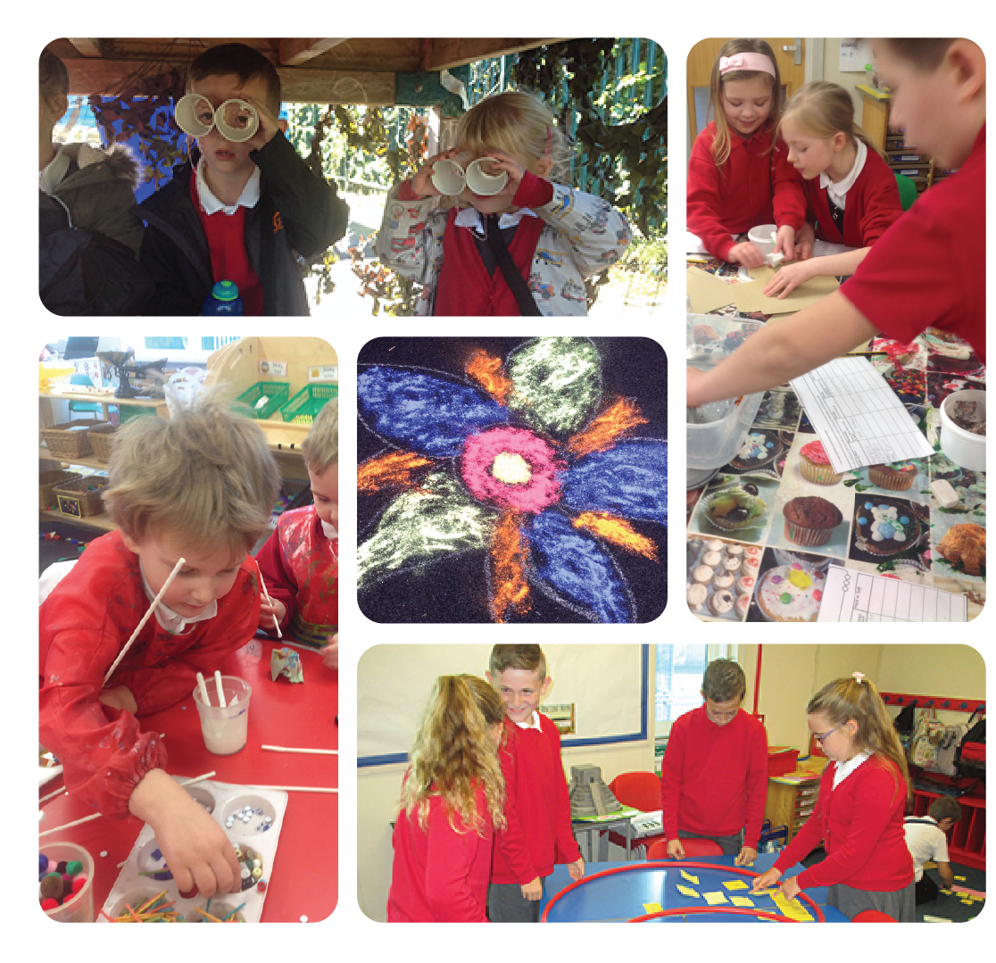

Headteacher Recruitment
Applicant Pack

Letter from the Chair of Governors
I am delighted you have taken an interest in applying for the post of Headteacher at White Mere Community Primary School.
We are situated on a small, private housing estate in Wardley, on the eastern edge of Gateshead.
We achieved ‘Good’ in our last two Ofsted inspections and with an enthusiastic leader strive to improve on this.
The Governors are seeking to appoint a Headteacher who is committed to the development of all our children. We believe that the starting point of a child’s journey in our school is for staff and parents to work together to fully understand the needs of each child to help them reach their full potential.
This is an exciting, challenging role and we are looking for a dynamic and determined individual with a clear vision of the future and steps to take us there. The Governors are seeking a special candidate who can quickly build upon the good things that exist and lead us on our journey to becoming an outstanding primary school.
You are welcome to visit the school and meet our enthusiastic pupils and staff in advance of your application. This can be arranged by contacting the school office at whitemere@gatedu.org or telephone (0191) 438 5008. The informal visit is not part of the selection process.

Keith Anderson
Chair of Governors
On behalf of the Governing Body of White Mere Community Primary School

Our Vision, Aims and Values

Our Vision
At White Mere Community Primary School, we provide an exciting and challenging environment in which all children and staff are given opportunities to develop to their best ability: academically, socially, spiritually and morally.
Working in partnership with parents and the community in an atmosphere of mutual trust, we recognise and provide for the rights of our pupils, encouraging them to have respect for themselves and others, and to develop as responsible members of our global society.
This is facilitated through a broad, exciting and enriched curriculum, equipping and developing our pupils as independent, lifelong learners.

Our Aims
White Mere Community Primary School aims to:
- Value every individual and to maximise the opportunities for his/her intellectual, moral, spiritual, physical, aesthetic and social development.
- Help pupils to develop lively, enquiring minds, the ability to take risks, to question and debate rationally and to apply themselves successfully to tasks.
- Create an interesting and stimulating environment, which reflects our vision and promotes a sense of community as well as an individual sense of self-worth.

Our Values
Our school reflects British values in all that we do.
We encourage our children to be creative, unique, open-minded and independent individuals, respectful of themselves and of others in our school, our local community and the wider world.
We aim to nurture our children on their journey through life so they can grow into safe, caring, democratic, responsible and tolerant adults who make a positive difference to British Society and to the world.
For further information about our school, please visit our website at www.whitemereprimary.org

You can also follow us on Twitter via @OffWhiteMere

The children of White Mere would like their Headteacher to be ...
“…someone who smiles all of the time.”
(Reception child)

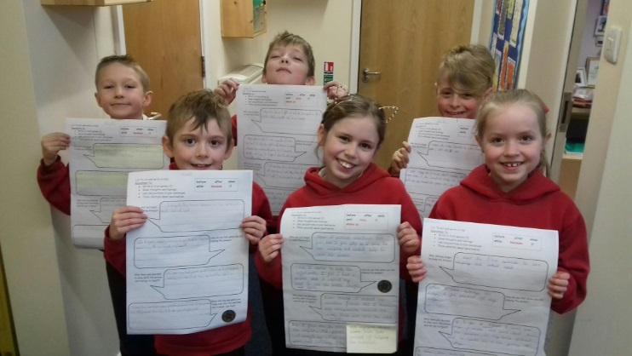
They would also like their Headteacher to be:
- A fun person
- Someone who listens to our ideas
- Someone we feel that we can talk to.
- Calm and consistent
- Comes into our classroom a lot
- Treats us all equally
- Someone with a big imagination
- A caring person
- Someone who is helpful
- Someone who can organise good trips!

Staff at White Mere would like their Headteacher to value their opinions and be:
- Approachable and human
- Committed to a child-centred approach to education
- A team player who will support all staff to have a good work-life balance
- A successful leader in teaching and learning, who can be inspiring and creative, but who will also be open to the ideas and philosophy of staff
- A good communicator with a sense of humour
- Someone who will continue the inclusive approach to education that we have established at White Mere
- Offers appropriate support and opportunities for CPD

The families of White Mere would like their Headteacher to be:
- An approachable, genuine and caring person
- A good listener
- An experienced / natural leader
- Someone who is fun and engages with children
- Someone who understands that the school is at the heart of the community and our passion for its success
- Someone who is enthusiastic and has drive and determination
- Someone who is a visible presence around school and on the yard

Life in Gateshead

The borough of Gateshead stretches almost 13 miles along the south
bank of the River Tyne and covers 55 square miles, making it the largest of
the five Tyne and Wear authorities. Gateshead is very close to Newcastle,
the major urban centre in the North East and has strong transport
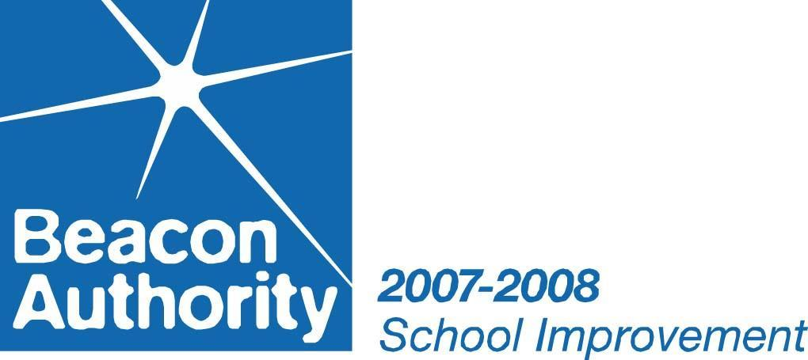
links to the city, the rest of the North East, and England. The
borough has undergone rapid transformation in recent years
with major physical redevelopment.

There is much to discover in Gateshead, from iconic and stylish
buildings, extraordinary landmarks and a vibrant, lively art scene
to exciting events, blooming parks and beautiful countryside.
Gateshead is fast becoming one of the biggest cultural quarters
in the country capturing the imagination of the world with The
Angel of the North - Britain's largest sculpture, The Gateshead
Millennium Bridge - the world's first tilting bridge, BALTIC -
the ambitious Centre for Contemporary Art, and The Sage
Gateshead – the regional music centre designed by Lord Foster.

Gateshead truly is a diverse and exciting place to live and work.

educationGateshead
Raising Achievement for All

Developing school staff is one of our most important goals – we believe the school team is the cornerstone to success. We are committed to offering a wide variety of exciting and stimulating training courses and conferences that are underpinned by current research and initiatives. Our dedicated and high quality inspectors, advisors, consultants and trainers have a wealth of knowledge and expertise in their chosen fields.

We have a wide range of training programmes in a variety of subjects that are delivered centrally. These are clearly focused on major priorities in schools and informed by the latest research and current initiatives. We try hard to let you know what’s new and effective in education.

We share a clear, common purpose with you to do the very best for children and young people, their families and their communities. We have significant collective experience of teaching, leading and managing schools, training and professional development, and carrying out Ofsted inspections. We are at the cutting edge of educational developments and practice through our innovative research programme and our direct involvement with many initiatives. We have established excellent links and relationships with local, regional and national policy and decision makers. Our support networks mean that if we cannot help, we will find someone who can.

There is a thorough programme of events to support newly appointed Headteachers in their first and second years, it includes:

- Visits to a wide range of schools throughout the borough: small schools, large schools, forest schools, special schools, new schools and schools housed in older buildings.
- Question and answer, information gathering sessions with officers from safeguarding, referral and assessment, finance, audit and insurance, human resources, governance and premises.
- Support of a Headteacher mentor during the first year who is experienced in all aspects of school leadership.

“The world of Headship can be a particularly daunting confusing one. In gaining a Headship in Gateshead, however, I was fortunate enough to access a wealth of support and expertise through the Induction Programme for Newly-Appointed Senior Leaders. Gateshead’s programme includes an array of sessions focusing on key aspects of school leadership: safeguarding, premises management, finance, HR, governance, admissions and more. The sessions –which are expertly crafted by a team of authority professionals – are delivered in a range of school settings, with current serving Headteachers laying bare their school communities, openly sharing their experiences of school leadership and offering advice to participants. For me, the induction programme served beautifully as a bespoke package of professional development, as well as a helping hand throughout some of the more challenging aspects of the job, and a wonderful opportunity to meet with colleagues and share experiences – positive and otherwise – in a supportive and encouraging environment.”
Joe Wheatley – St Mary’s Primary School

“Gateshead leadership induction programme is excellent. Each month essential topics were covered, which provided knowledge of not only the systems in Gateshead, but also key people. I looked forward to these sessions as they were enlightening and gave me the opportunity to network with other new Headteachers and Deputies. I loved the fact we were able to look around other schools and ask experienced Headteachers countless questions. As a newly qualified teacher in Gateshead some years ago, I had the very best support and was not disappointed to find that on my return to Gateshead, the quality of the service is still second to none.”
Tracy Musgrove – St Oswald’s RC Primary School

educationGateshead, the very best for our children and young people.

Application Details
White Mere Community Primary School is situated within the heart of the local community in Wardley, Gateshead. It provides a positive, inclusive atmosphere; there is a strong commitment to provide the best for each and every child. The Governing Body of this good school is seeking to appoint a Headteacher who is well qualified, with the vision, determination and ability to lead the school confidently into the future.

You will be an exceptional practitioner, who is able to understand the skills required of a classroom teacher and disseminate and drive innovation and effective teaching and learning strategies throughout the school.

We are proud to offer:

- Delightful children who are happy and eager to learn and who will brighten your day, every day!
- A dedicated, hardworking and enthusiastic staff team who genuinely care about the school
- A fully committed governing body who are very supportive of the school’s leadership team
- A supportive community who are invested in their school
- Strong and effective links with the Local Authority and local schools

We are looking for a leader who:

- Is successful and inspirational with a proven track record
- Is innovative, organised and passionate about improving educational standards
- Will motivate children to achieve their full potential in school and in life, and continue to work with us on our journey to become an outstanding school
- Who is approachable, visible and supportive of children, staff and parents
- Has excellent communications skills and the ability to work collaboratively with governors, staff, parents and the community for the benefit of all pupils
- Is aware of the importance of all staff, including themselves, having a good work-life balance
- Can consolidate and build upon what we have already achieved by implementing further strategies to improve and raise standards, achievement and aspiration.

Closing date: Friday 5th April 2019
Shortlisting: Week commencing 8th April 2019
Interviews: Tuesday 23rd & Thursday 25th April 2019

We would welcome you on a visit to our school; this can be arranged by contacting the school office at whitemere@gatedu.org or telephone (0191) 438 5008.

Job Profile
Overall | To meet the requirements of a Headteacher as set out in the School Teachers’ Pay and Conditions Document, school and local authority policies.
Responsible to | School governing body and Strategic Director Care, Well-being and Learning.
Strategy | In consultation with staff, governors and children to create and maintain the ethos, values and aims of the school.
 | To have high expectations and lead by example.
 | To work with the governing body to determine the strategic direction of the school.
 | To keep under review the work and organisation of the school and continue to evaluate the effectiveness of the curriculum in the light of children’s needs, national and local priorities.
 | In consultation with staff, governors and children to draw up and implement a school improvement plan.
 | To ensure implementation of key statutory policies, including equal opportunities, anti-discrimination, special educational needs and disability and to promote an understanding of the diversity of life in Britain and of fundamental British values.
 | To provide clear strategic direction for the school, which achieves the highest quality educational provision across all three key stages including personal, social and academic outcomes.
 | To ensure that the school benefit from a rigorous self-evaluation framework which substantially contributes to improved outcomes in the school.
 | To take the lead and advise the governing body in the recruitment and appointment of staff.
 | To ensure that current educational initiatives are incorporated effectively within the school’s drive for improvement.
 | To build and maintain safe, caring, welcoming, happy, stimulating and challenging learning environments.
 | Attendance at and participation in meetings relating to the curricular administrative, organisational, pastoral and managerial arrangements for the school.
Finance and Resources | To plan, manage and monitor the use of finances and resources effectively to achieve the aims of the school.
Curriculum and Learning | To lead the educational development of the school and ensure that each child's educational programme meets their individual needs.
 | To monitor and evaluate the standards of teaching and learning and children’s progress across the school.
 | To provide for the well-being, involvement, emotional, social and personal development of children to complement their academic development.
Staffing | To work with other senior leaders to coach staff to develop their teaching skills based on areas of development identified in observations.
 | To manage and motivate all staff to ensure the curriculum is delivered effectively.
 | To provide opportunities for continuing professional development for all staff.
 | To lead and support the leadership team individually and collectively.
 | To manage the performance of all staff in line with statutory requirements and delegate responsibilities where appropriate, ensuring the highest quality of performance.
Liaison | To work closely with the governing body to ensure the school operates effectively and efficiently, leading to highly effective provision across the school.
 | To develop positive relationships with parents, the local authority, other schools and the local community.
 | To arrange for parents to be given regular information about the curriculum, progress of their children and other matters affecting the school.
 | To work effectively with other professionals to ensure the best possible skills and resources are available for all children in order to maximise their potential.
 | To provide regular reports to the governing body on the impact of the work of the school.
 | To provide opportunities for developing inclusive practice for both children and staff in partnership with relevant organisations.
Premises | To create a welcoming, safe, stimulating environment both indoors and outdoors in which children, staff and visitors feel comfortable and which is conducive to learning.
Personal Development | To engage actively in performance management and continuing professional development to ensure professional skills are kept up to date and developed.

The Job Description is current at the date shown, but in consultation, may be changed by the governors to reflect or anticipate changes in the job commensurate with the grade and job title.

The Headteacher will be expected to comply with any reasonable request from the governors to undertake work of a similar level that is not specified within this job description.

Headteacher Specification
White Mere Community Primary School

ATTRIBUTE | ESSENTIAL | DESIRABLE
TRAINING AND QUALIFICATIONS
- Qualified Teacher Status. | E
- Degree or evidence of professional qualification in education. | E
- Higher Degree or evidence of further study. |  | D
- Post-entry Curriculum or Management Qualification. |  | D
- National Professional Qualification for Headship (unless existing HT with some years of experience). |  | D
- Recent participation in a range of relevant in-service training. | E

EXPERIENCE OF TEACHING AND SCHOOL MANAGEMENT
- Leadership experience at Headteacher or Deputy Head level  (minimum 3 years for the latter). | E
- Proven management skills and a record of positive achievement. | E
- Minimum five years' experience in a school for children of primary age (in more than one school/setting/key stage). | E
- Experience of teaching in a school with socio-economic challenges. |  | D
- To have effectively managed whole school change, for example introduced a new initiative or procedure, developed a strategy which impacted significantly upon children's learning, and delivered in-service training. | E
- To have had involvement with preparing and monitoring budgets. | E
- To have had involvement with school improvement-planning process, (particularly monitoring and evaluating the effectiveness of actions), school self-evaluation process, Ofsted inspection, Child Protection issues. | E
- To have involvement of working with a governing body. | E
- To have experience of implementing or monitoring safeguarding practice within a school. | E
- To have experience of inclusive educational practice within a school | E
- To have experience of working with trainee teachers |  | D

ATTRIBUTE | ESSENTIAL | DESIRABLE
PROFESSIONAL KNOWLEDGE AND UNDERSTANDING
Applicants should be able to demonstrate a good knowledge and
understanding of the following areas relevant to primary education development.
- Children’s educational and personal development. | E
- School leadership and management. | E
- Curriculum and assessment, including subjects and cross-curricular aspects. | E
- Effective teaching and learning strategies. | E
- School improvement strategies. | E
- Local and national policies, priorities and statutory frameworks including the Early Years Foundation Stage | E
- Role of Governing Body. | E

PERSONAL SKILLS AND ABILITIES
Applicants should be able to provide evidence that they have the necessary personal skills and abilities required by the post.
- Excellent communication skills, both written and verbal. | E
- Highly effective interpersonal skills. | E
- Ability to motivate and enthuse all members of the school community. | E
- Effective ICT skills. | E
- Effective and efficient organisational skills including timekeeping. | E

OTHER REQUIREMENTS
- Application forms should be completed in full. | E
- Applications submitted on line. | E
- Applications should address the criteria identified in the person specification and be relevant to the school. | E

CONFIDENTIAL REFERENCES AND REPORTS
- Written reference(s) only. | E
- Confirming professional and personal knowledge, skills and abilities referred to above. | E
- Positive recommendation from current employer. | E

