School Information

For the post of

Headteacher, Norham St Ceolwulf’s First School

The Governors, Diocese and the Local Authority would like to thank you for your interest in this post. We believe that Northumberland is both a beautiful and rewarding place to live and work. You will find enclosed information about the County, the Local Authority and the school, which we hope will encourage you to apply.

If, after reading the enclosed information, you feel you wish to apply for the post, please complete the application form and return it by noon on the Friday 19th February 2018 by:

applying online on the TES Schools Portal.

https://www.tes.com/jobs/browse?locations=Europe%3AUnited%20Kingdom%3AEngland%3ANorth%20East%20England%3ANorthumberland&positions=Leadership

Thank you for your interest and we look forward to receiving your application.

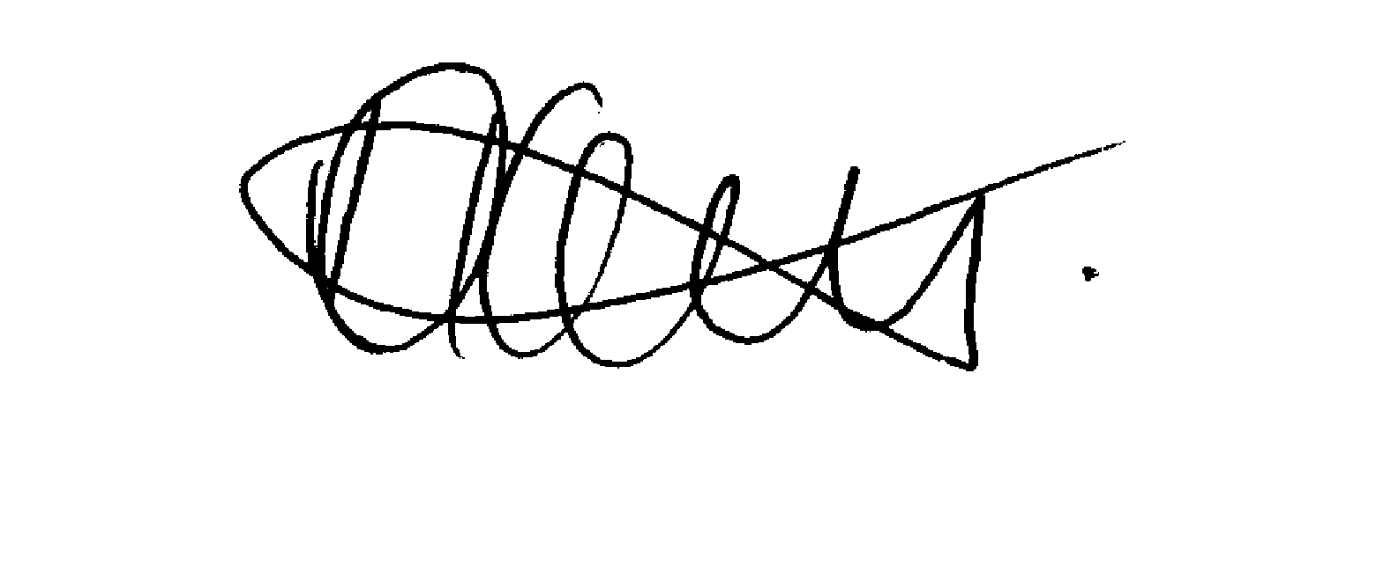

Mrs Daljit Lally
Executive Director of Wellbeing and Community Health Services

