Driving Instructor/Assessor £25,694 - £27,394 + Benefits

We have an exciting opportunity for certified approved Driving Instructor’s with experience in teaching and assessing.
The Role
The purpose of this role is to assist the Vehicle Training Service Team Leader with the planning and delivery of all aspects of driving instruction including LGV and forklift trucks.
Required Skills/Experience:

- An experienced driving instructor with an assessing qualification.
- You will have experience of planning and delivering lessons on driving theory and driving laws.
- You will hold a Full Class C, D1 and E UK or EU driving licence held for a minimum of 3 years.

What we can offer you

Tyne and Wear Fire and Rescue Service Headquarters are based in a purpose build office in Washington, with ample free parking and easy access from the A1 and A19. On site facilities include catering facilities and an onsite gym. The role also benefits from an attractive benefits package, including up to 41 days’ holiday, Local Government Pension scheme, and access to a range of social and volunteering opportunities.

Closing Date: Monday 30 January 2017 12:00 hours

Interviews: Week commencing 6 February 2017

Please visit https://www.northeastjobs.org.uk to apply for this role

We positively welcome applications from all individuals within the community particularly those who are from under-represented groups.
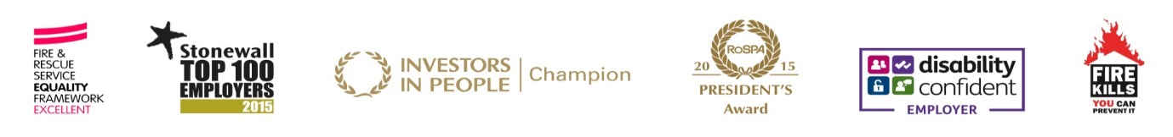
Working towards equality and diversity for the community we serve

