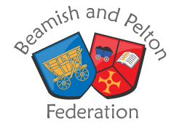
Person Specification – EYFS Teacher

 |  | Essential | Desirable | Evidence
Qualification | 1 | DFE recognised qualified teacher status | Graduate Status | Application  Registration at interview
Professional Development | 2 |  | Evidence of relevant and recent professional development | Application  Registration
 | 3 | Evidence of keeping abreast of educational developments | Evidence of innovative practice eg Forest Schools | Application/ interview
Experience | 4 | Excellent Foundation Stage practitioner | Experience in Nursery and Reception classes | Application/ references/ interview/ lesson observation
 | 5 | A commitment to Early Intervention and meeting all pupils needs. |  | Application/ interview/ lesson observation
 | 6 | Experience of working with a range of SEND pupils.
Skills and attributes | 7 | An effective team player | Experience of organising and planning for Teaching Assistants. | References/ interview
 | 8 | The ability to work flexibly and sensitively with the whole school community |  | References/ interview
 | 9 | Willingness to contribute to the extended life of the school. |  | Application/ references/ interview
 | 10 | Excellent communication skills |  | Application/ references/ interview
 | 11 | Good behaviour management skills | Knowledge of the restorative approach to behaviour management | Application/ references/ interview/ observation
Knowledge | 12 | Up-to-date knowledge of Early Years Foundation Stage curriculum |  | Application/ interview
 | 13 | Understanding of Assessment in Early Years |  | Application/ interview/ observation

