St Mary’s RC Primary School

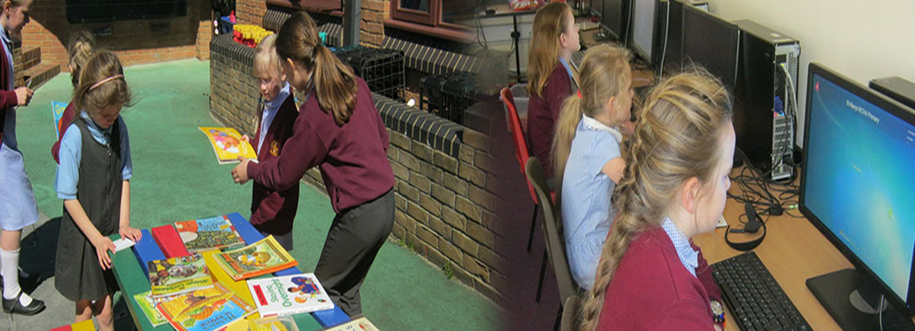

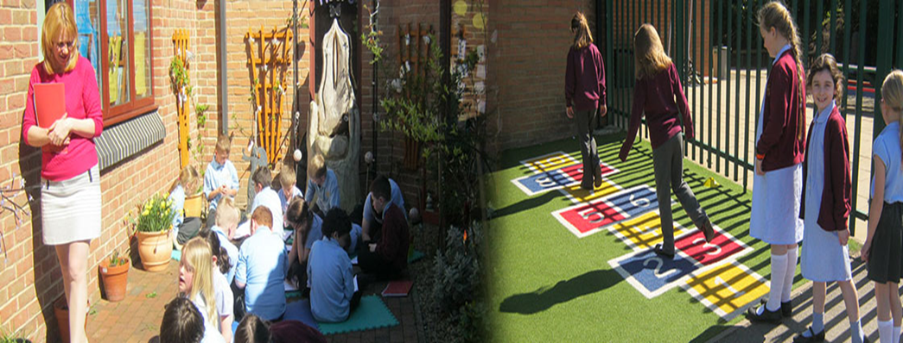

Job Description:
Caretaker

ORA BENE LABORA BENE

St Mary’s RC Primary School:
Caretaker Job Description

- Post Title: Caretaker

- Post Number: N9623 (JRD)

- Grade: Grade 3

Job Evaluation Reference Number:

- Location: St Mary’s RC Primary School, Blackhill

- Relevant to this Post: (Please delete where not applicable)

Disclosure & Barring Service: Subject to DBS Enhanced disclosure

- Organisational Relationships:

The post holder will be accountable to the Headteacher.

The post holder will be responsible for line management of the Cleaners.

- Description of Role:

The post combines the care of the site and the oversight of the maintenance of the premises in conjunction with the Headteacher. This may require close working with outside contractors and external providers.

The Caretaker will be responsible for the security of the site, the premises and its contents, (including the operation of fire and burglar alarms and key-holder responsibilities), lighting, heating, maintenance and operation of plant. The post holder will:

- Co-ordinate the work of any of the other cleaning staff
- Daily supervision of the cleaning teams across all buildings
- Monitor attendance and raise/report any long-term and on-going absence issues with the School Office/Headteacher

- Duties and Responsibilities Specific to this Post:

Listed below are the responsibilities this role will be primarily responsible for:

- Porterage and other duties arising from the use of the premises
- General duties would include good house keeping (e.g. securing screws, hinges, doors, minor plumbing and decorating, etc.)

- Minor plumbing and decorating

- Jet washing the EYFS area half termly as a minimum
- Co-ordinate and undertake the relevant Health and Safety/buildings checks, inspections and Fire Practices, record findings and addressing faults, maintaining up to date COSHH risk assessments, site risk assessments and relevant paperwork/systems
- Notifying the School Office when relevant stock needs to be reordered and placing orders

- Liaising with the School Office and Headteacher over calendar dates and building works, including liaising with Contractors to co-ordinate works. Oversee contractors on the premises.
- The cleaning of agreed designated areas in the establishment and maintaining high standards in these areas in accordance with the cleaning specification

- Maintaining floor surfaces in accordance with requirements of the Authority's cleaning specification, the hall and other floor finishes, and emergency cleaning duties as and when required
- To be available and to attend for the purpose of lettings for school use (e.g. Governors' meetings, open evenings, school plays etc)
- In cases of emergency outside the working week e.g. intruders, fire, flood etc. the post holder will be required to attend for such action as is required.

- To promote and maintain the good order and condition of the whole site, the removal of graffiti from internal and external surfaces
- To remove human spillages, for example, blood, vomit etc. following the emergency spillages procedure
- To oversee the cleaning team and carry out regular cleaning inspections and address/report any findings to the Headteacher or his/her designated representative
- To ensure that all the exterior surfaces, including any artificial areas, are kept in a clean and tidy condition, including the emptying of litter baskets daily, the cleaning of drains and gullies as required and salting and de-icing of hard surface areas during the winter months and moving of snow to ensure access to the premises. To attend to refuse bins and the maintenance of an orderly boiler house area. Also to ensure that the site is free from animal fouling. That the school frontage is clear of any animal fouling or glass (these elements may be delegated to other staff as required).
- To check the premises regularly and to liaise with the Headteacher whenever the need for repairs arises
- To carry out routine maintenance tasks such as making good damaged paintwork, minor repairs and any other tasks deemed by the Headteacher to be part of the routine maintenance
- To undertake key holding and security duties
- Setting out furniture, etc., as required by the Headteacher or his/her delegated representative
The generic responsibilities, which will be undertaken in support of the above work, include the following (if applicable):

- Common Duties and Responsibilities:
(Where applicable)

9.1 Quality Assurance
To set, monitor and evaluate standards at individual, team performance and service quality so that the school’s requirements are met and that the highest standards are maintained.

To establish and monitor appropriate procedures to ensure that quality date are reported and used in decision making processes and to demonstrate through behaviour and actions a firm commitment to data security and confidentiality as appropriate.

9.2 Communication
To establish and manage the team communications systems ensuring that the school’s procedures, policies, strategies and objectives are effectively communicated to all employees.

9.3 Professional Practice
To ensure that professional practice in the school is carried out to the highest standards and developed in line with the school’s stated objectives of continual improvement in quality of its service to internal and external customers.

9.4 Health and Safety
To ensure that the Health and Safety policy, organisation arrangements and procedures as they related to areas, activities and personnel under your control are understood, implemented and monitored.

9.5 General Management (where applicable)
To provide vision and leadership to employees within a specialist team, ensuring that effective systems are in place for workload allocation and management, the application of the school’s policies and procedures, including those relating to equality, supervision and appraisal and all aspects of their performance, personal development, health and welfare.

9.6 Financial Management (where applicable)
To manage a designated budget (as required) ensuring that the school achieves value for money in all circumstances through the monitoring and control of expenditure and the early identification of any financial irregularity.

9.7 Appraisal
All employees will receive appraisals and it is the responsibility of each employee to follow guidance on the appraisal process.

9.8 Equality and Diversity
To ensure our commitment is put into practice we have an equality policy which includes responsibility for all employees to eliminate unfair and unlawful discrimination, advance equality of opportunity for all and foster good relations.

9.9 Confidentiality
All employees are required to undertake that they will not divulge to anyone personal and/or confidential information to which they may have access during the course of their work.

All employees must be aware that they have explicit responsibility for the confidentiality and security of information received and imported in the course of work and using school information assets. The school has a Personal Information Security Policy in place.

9.10 Induction
The school has in place an induction programme designed to help new employees to become effective in their roles and to find their way in the organisation.

9.11 Safer Recruitment
This organisation is committed to safeguarding and promoting the welfare of children and young people and expects all employees and volunteers to share this commitment.

The above is not exhaustive and the post holder will be expected to undertake any duties which may reasonably fall within the level of responsibility and the competence of the post as directed by the Headteacher.

