St. Wilfrid’s RC Primary
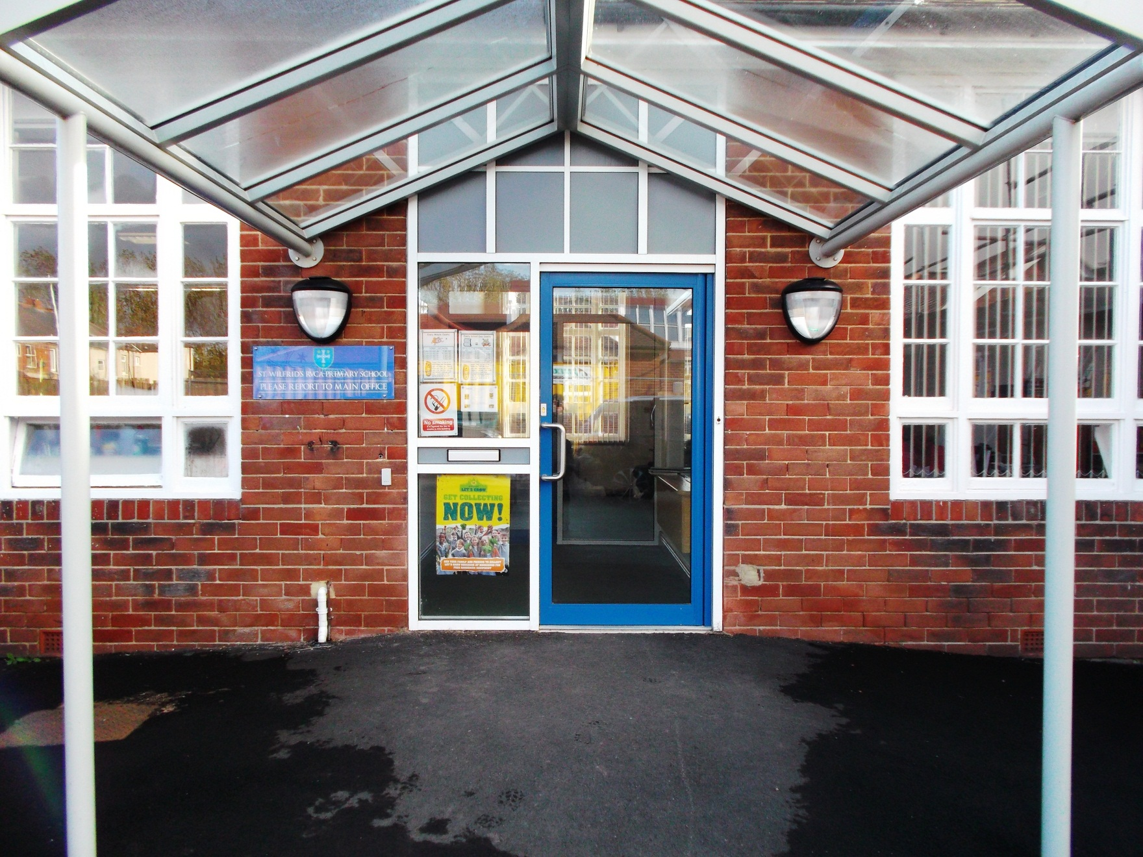
Inspired by Christ we grow and learn together, reaching our fullest potential.

Class Teacher Post September 2019.

Dear Candidate
We are delighted that you are interested in coming to teach at our school.
St Wilfrid’s opened as a primary in 2011 and has gone from strength to strength ever since. In our most recent inspection (March 2018) we were graded as good in all areas. Inspectors said that “there is a determination to provide every opportunity for pupils to thrive within the school’s caring and inclusive community” and that “good quality teaching…enables pupils to make great strides in their learning”.
Our Catholic ethos is central to our school. In our recent Diocesan inspection (March 2018) we were graded as good in collective worship and Religious education. The Catholic Life of the School was graded as outstanding.
We have a highly skilled, supportive, friendly and dynamic team who are rapidly moving the school forward and improving outcomes for all of our pupils.
We are committed to developing staff in all roles and at all stages in their careers and we offer many training opportunities through external courses and in-house training with partner schools in Blyth, the Catholic Partnership and through our membership of The Dales Teaching School Alliance. We encourage staff to take the lead in areas which interest them and that will enhance our pupil’s development. At present we are involved in national and local initiatives such as Careers Benchmarks for Primary Schools, Port of Blyth STEM hub, Great North Maths Hub, Woodhorn Arts project, The Great North Elmer Parade. We run a range of pastoral groups such as the School Council and House Captains group, Rainbows, and Thrive Support. We have a Forest School and have just started a Community Chest “Farm to Fork” project as well as Voiceband, music groups and lots of residential and day trips.
We have enthusiastic and well behaved pupils and our house structure allows children from across the school to meet together in mixed age groups on a regular basis. We promote British Values through our extensive PHSE, SpMSC and RE programmes.
St Wilfrid’s is based in the port of Blyth. We are a short walk from the beach and harbour and are involved in local initiatives such as the Blyth Tall Ships project.
We hope that you will consider applying for our teaching position and you are welcome to visit our school.
We look forward to meeting you
Yours sincerely

Mrs Pauline Johnstone
Head teacher.

Job Description; Class teacher.
This job description is in addition to the requirements of the School Teachers’ Pay and Conditions Document and the relevant professional standards.

Key Purpose.
- To teach a class of pupils and ensure that planning, preparation, recording, assessment and reporting meet their varying learning and social needs.
- Maintain the positive ethos and core values of the school inside and outside the classroom and when off site.
- Contribute to constructive team building amongst teaching and non-teaching staff, volunteers, parents and governors.
- Ensure current national professional requirements are met to a high standard.
Main Duties.
- Ensure the welfare and safeguarding of all children through rigorous implementation of the school and national policies and procedures.
- Promote equality and treat everyone with fairness and dignity.
- Plan appropriately to meet the needs of all pupils through high expectations, clear targets based on prior attainment, differentiation of tasks and challenging objectives.
- Plan and deliver the curriculum within the framework of current national and school requirements.
- Use quality marking and feedback, accurate formative and summative assessments to accelerate children’s progress and record and report progress and attainment.
- Plan and deliver opportunities to develop the social emotional moral spiritual and cultural aspects of children’s learning.
- Plan and resource a vibrant classroom which will encourage all aspects of children’s involvement in learning.
- Secure excellent behaviour through outstanding classroom management and application of whole school strategies.
- Consistently teach at a good and outstanding level.
- Implement and support initiatives decided by the head and senior leadership team.
- Establish positive communication and consultation with parents about all aspects of their child’s education.
- Communicate and co-operate with outside agencies.
- Ensure effective use of support staff.
- Continue professional development and actively engage in the performance management system
- Recognise health and safety responsibilities and take care of self and others complying with the school and statutory health and safety policy and procedures.
- Play an active part in the school team by being actively involved in decision making on preparation and development of policies, programmes of study, teaching materials and resources, methods of teaching and pastoral arrangements.
- Lead a curriculum area or aspect.
- Undertake any additional duties and tasks under the reasonable direction of the head teacher.

Person Specification- Class teacher.
Key Criteria | Essential | Desirable | Application, Interview process, references.
Qualifications and experience | Qualified Teacher status. | A degree or equivalent qualification.  Evidence of further relevant study | Application.
 | Evidence of appropriate continuing professional development.  ICT competent and confident  A track record of good and outstanding teaching in the primary phase. | A subject specialism.  CCRS or the willingness to study for this qualification.  Evidence of involvement in successful whole school curriculum and pastoral development | Application, Interview Process, References.
Knowledge and Experience | A thorough, up to date knowledge of the range of teaching, learning and behaviour management strategies and how these relate to high achievement and attainment.  A thorough understanding of the national curriculum and a range of assessment requirements and arrangements.  Experience of raising standards through quality teaching for all pupils including underachieving pupils.  Experience of promoting positive behaviour conducive to learning and which is focussed on raising standards.  Knowledge of the legal requirements, national policy and guidance on safeguarding children.  Knowledge and understanding of the implications of equal opportunities, British Values and inclusion and how these can be addressed in schools. | Knowledge of effective monitoring, data analysis and self-evaluation.  Creative ideas and support for the future development of the school.  Experience of promoting highly effective communications within and between teams and other stakeholders in the school community.  Know how to use local and national data to evaluate the effectiveness of teaching. | Application, Interview Process, References
Teaching Skills and Abilities | Able to plan and prepare effectively.  A clear understanding of assessment to inform planning.  Able to set high expectations and standards, and provide a role model for pupils and staff.  Evidence of good classroom management skills.  The ability to use ICT effectively to engage and challenge pupils.  Able to create a happy, challenging and effective learning environment.  Commitment to inclusion, safeguarding and welfare of pupils.  Work effectively in partnership with parents, governors and the wider community  Good understanding of effective procedures for managing and promoting positive behaviour among pupils.  Good understanding of the role of parents and the community in school improvement and how this can be practised and developed. | Evidence of good, successful teaching in the primary sector.  Evidence of consistent and effective lesson planning to meet differing learning needs.  Experience of subject leadership.  Experience of monitoring and evaluation at phase or school level.  Clear understanding of data analysis and the impact this can have on achievement and attainment  Willing to contribute to the school’s extracurricular activities. | Application, Interview Process, References
Personal Qualities | Suitability to work with children. |  | Reference.  DBS
 | Commitment to Catholic education and ability and enthusiasm to promote the to the school’s distinctive Catholic ethos.  Ability to develop good relationships, communicate effectively and work as part of a team to make an effective contribution to high morale.  Ability to communicate effectively with parents, governors and wider community.  A solution focussed mind-set and determined “no excuses” approach to raising standards.  Good organisational skills.  Ability to prioritise and manage time effectively.  Enthusiasm, determination and drive to inspire others to achieve high standards. Lively and creative approach to all aspects of good stress and workload management and sense of humour.  Able to be open and constructive, able to accept feedback and act to improve practice.  Able to manage own and support others workload appropriately.  Self-confident with a collected professional manner  A good record with regard to punctuality and attendance at work | A practising Catholic. | Application, Reference,  Interview Process.

Application Process.
Applications must be completed on the CES application form. No other formats will be accepted. You should include three referees, one of which may be your parish priest or faith leader. The selection process will be as follows;

Selection Process
Advertised. | 24.5.19 | Closing date;7.6.19
Shortlisting. | 10.6.19
Interview Process | 17.6.19
Classroom Observation
Marking and feedback task

Collective Worship
Interview

Visits to the school are encouraged. Please ring to arrange a convenient time.

