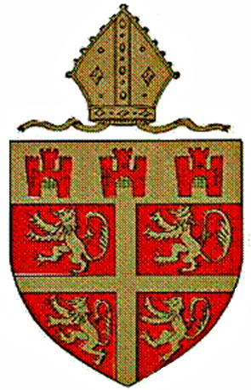
The Diocesan Boards of Education
of Durham and Newcastle

Working Together to support Schools and Parishes

Statement of Purpose

Church of England Boards of Education fulfil a number of statutory functions in relation to church schools and church educational endowments. Our aim is to ensure that outstanding education is provided in our church schools, and to foster high quality engagement with young people and adults in schools and parishes across the dioceses.

Church Schools have a high and positive profile in the world of education at national and local level. The most recent evidence of this is the Chadwick Report entitled ‘The Church School of the Future” http://www.churchofengland.org/media/1418393/the%20church%20school%20of%20the%20future%20review%20-%20march%202012[1].pdf

setting out a commitment to fully supporting Church schools and academies and recognising the central role of such schools in the publicly-funded schools sector. This brings with it the responsibilities of ensuring that Church of England schools continue to be both distinctive and inclusive providers of outstanding education at the heart of local communities. The increasing emphasis on a diversity of ‘providers’ of education through maintained schools means that the Church is being called to greater accountability for the use of public funds in providing education of high standard, in buildings that are well maintained, and in accordance with key national policy objectives. The success of the dioceses in responding to the aspiration of the national church for an increased engagement with secondary schools (including academies) has led to a big increase in provision in both our dioceses, changing the profile of support that is needed. In addition to this, the drive to promote ‘community cohesion’ is leading to increasing opportunities for the Church to engage positively with non-Church schools.

Parishes are looking for new ways to engage with children and young people. Churches and schools exist to serve the areas in which they are placed, and working together can contribute to the building of strong and vibrant communities. Church schools are an invaluable resource for the whole diocese, bringing opportunities and insights from the world of education and enriching the wider mission and ministry of the church.

Broadly the same issues and challenges face both dioceses. Board officers have been working for some time on a number of initiatives including the administration of the Statutory Inspection of Church Schools requirements; a joint Further Education task group working with colleges to explore the faiths, beliefs, values and community cohesion agenda; provision of support materials and training for RE and Collective Worship; and work with curates in their initial training programme. This work has enabled us to share expertise, build capacity and make more effective use of our resources.

Since 2010 the Durham and Newcastle dioceses have agreed that education joint working should be consolidated as a positive response to the demands of the Government’s agenda for school reform. This has allowed the already excellent work that was being done to develop further by increasing the combined capacity of both Boards to respond to the challenges facing all providers of education and offering a service for schools that can be more sharply focussed. Most importantly the Boards now have access to the expertise they need to better support not only their church schools in the provision of outstanding education, but also parishes in engaging with this vital part of the mission activity of the church.

