JOB DESCRIPTION
Post Title: |  | Head of Pensions Governance & Investments
Grade and Salary Scale: |  | R SCP 59 – 63
Department and Service:  Responsible To:  Post Ref: |  | Finance, Governance & Support  Strategic Director of Finance, Governance & Support  G842

Pensions Governance and Investments:
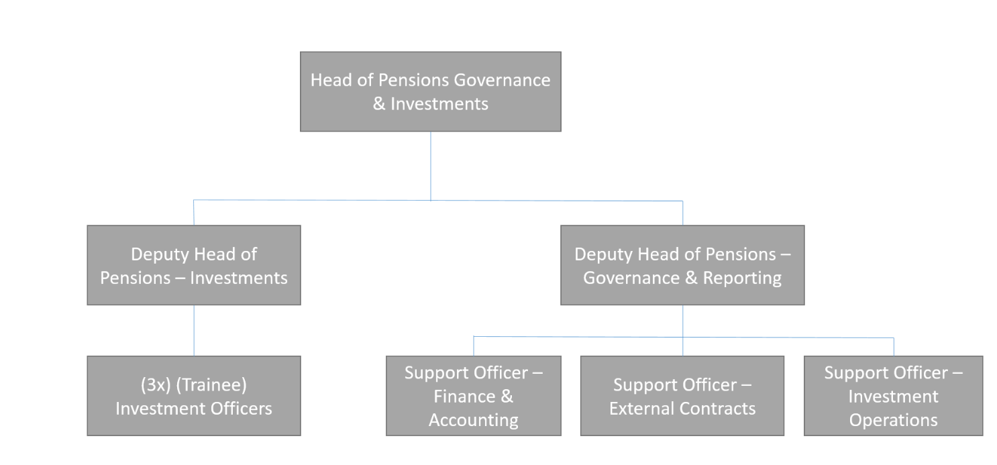
Middlesbrough Council (the Council) is the Administering Authority of the Teesside Pension Fund (the Fund) and administers the Local Government Pension Scheme (LGPS) on behalf of its stakeholders which currently include:

- around 70,000 current and former members of the Fund, and their dependants
- over 150 employers within the Teesside Fund
- local taxpayers within the council areas participating in the Teesside Pension Fund.

The LGPS, unlike most other Public Sector schemes, is a funded scheme with contributions from employers and employees invested in order to meet future liabilities. Every three years the Fund’s actuary is required to carry out a full actuarial valuation. The purpose is to calculate how much employers need to contribute to ensure there are sufficient funds to meet future pension payments. In addition, the actuary also calculates to what extent the Fund’s current assets meet its existing liabilities, expressed as a funding level, and at the last actuarial valuation (March 2016), the funding level was 100%.

The Administering Authority has delegated responsibility for the management and stewardship of the Fund to the Teesside Pension Fund Committee (the Committee). The Committee has plenary powers to manage the Fund and make decisions without interference from the Council. In compliance with the Public Service Pensions Act, the Council has also set up the Teesside Pension Board to assist the Council, and therefore the Committee, to ensure the Fund is management efficiently and effectively, and in compliance with the Pension Regulator’s code of practice.

The Strategic Director Finance, Governance and Support is the lead responsible officer for running the Fund. The Pensions Governance and Investment section assists the Strategic Director in the running of the Fund, with the Head of Pensions Governance and Investments leading and managing this section.

The Fund was predominantly internally managed, i.e. its own employees managed the investment assets for the Fund. Current LGPS regulations require all LGPS funds to pool their investments into a pooling arrangement with other LGPS funds. The Fund has assisted in the development and creation of a co-owned asset management company and now is a partner of the Border to Coast Pension Partnership (BCPP). In the near to medium term, most of the Fund investments will be managed through BCPP, so it will be integral to the Fund to build a good relationship with BCPP and BCPPs other partners.

Some investment assets will remain with the Fund to manage, including cash, property (in the short to medium term), partnership funds and local investments. In addition, the Fund will provide an effective and efficient treasury management “dealing service” for Middlesbrough Council.

The Fund outsources a considerable amount of its pension administration to Kier Services (Workplace Services). However, it is still the responsibility of Middlesbrough Council as the Administering Authority to ensure that pensions are administered effectively and in compliance with both over-riding pension legislation and LGPS legislation.

Pensions, Governance and Investments are part of the Finance, Governance and Support Directorate at Middlesbrough Council. As a member of the Finance, Governance and Support management team this post holder has wider corporate responsibilities across the directorate, e.g. for helping to develop the directorate, work collaboratively on resources and other projects, and implement council wide initiatives.

Purpose of the Post:

Reporting to the Strategic Director Finance, Governance and Support (S151 Officer), and with direct responsibility for the Pension Governance and Investment Section, the Head of Pensions Governance and Investments will lead the Fund, ensuring it adheres to legal and national pension regulations, provides a strategy to manage the Fund’s investment assets and liabilities and the Fund delivers a quality, customer focussed administration service.

The Head of Pensions Governance and Investments will represent the Fund both within the Council and with external bodies, and work closely with the Strategic Director Finance, Governance and Support, both Pension Committees (Teesside Pension Fund Committee and Teesside Pension Board) and other key external service providers to the Fund (e.g. Actuary, BCPP & Kier Group).

Duties and Responsibilities:

- Responsibility for providing effective arrangement for the governance, investments and administration of the Teesside Pension Fund.
- Provide strategic advice to the Teesside Pension Fund Committee to ensure the establishment of an investment strategy and funding strategy.
- Implement and continuously review the Fund’s investment and funding strategies.
- Provide strategic advice to the Teesside Pension Board to ensure the Board can perform its responsibility for assisting the Administering Authority (Middlesbrough Council):
- To secure compliance with the Regulations, any other legislation relating to the governance and administration of the Scheme, and requirements imposed by the Pensions Regulator in relation to the Scheme; and
- To ensure the effective and efficient governance and administration of the Fund.
- Investment activity of the Fund’s officers is governed by a Management Agreement, as part of the Investment Strategy Statement for the Fund, with the Teesside Pension Fund Committee. This Agreement covers matters such as conduct, personal dealing, training and limitations to investment discretion. The post-holder will be bound to comply the Agreement.
- Oversee and have ultimate responsibility for the day-to-day investment activities of the Fund in order to maximise the return on investments and have responsibility for ensuring that the Fund’s policies on Shareholder Governance are implemented.
- Liaise with the Fund’s investment advisors and other advisors to develop long-term strategies to meet the liabilities of the Fund and recommend such strategies to the Pension Committee.
- Manage the relationships with the Fund’s external investment management providers, including BCPP, and other service providers to ensure that contractual obligations and the future requirements of the Fund are met.
- Plan, implement and continually review systems and procedures, which will ensure the efficient and effective control and security of the Fund’s assets.
- Responsibility for the design and implementation of comprehensive systems of performance targets, including an annual budget, as part of the annual business plan for the Fund.
- Provide strategic advice to the Teesside Pension Fund Committee to ensure the establishment of a customer focused pension administration strategy.
- Implement and continually review the pension administration strategy and oversee the activities of the outsourced Pensions Administration unit.
- Responsibility for providing an efficient and effective treasury management “dealing service” for the Council, including the arrangement of new long term and short term loans, rescheduling existing loans and arranging the investment of surplus cash in accordance with the Council’s Treasury Management Practices.
- Ensure national policy changes are implemented effectively and are in the best interest of fund members and demonstrate sound governance principles.
- Liaise with the Council’s Financial Governance and Revenues Section to deliver the Annual Report and Accounts in accordance with CIPFA guidance and statutory deadlines.
- As a senior manager of the Council and a member of the Finance, Governance and Support management team:
- Contribute towards the effective management of the Council/Directorate and the achievement of the Council/Directorate’s corporate aims, and support the development and implementation of corporate projects and initiatives.
- Advise and support Elected Members of the Council’s policies and procedures and professional obligations as they relate to pensions and investments.
- Work in partnership with other Heads of Service, each a key member of the Council/Directorate’s Management Team, leading the service towards the achievement of the overall corporate vision by pursuing best practice and innovative ways of working.
- Develop positive, influential and productive internal and external partnerships.
- Contribute to corporate teams tackling cross-cutting issues.
- Deputise for the Strategic Director as required.
- Ensure that effective performance management systems are developed and maintained to ensure the delivery of efficient services, develop effective performance management and quality assurance arrangements to drive improvements to service delivery and improved outcomes, and lead and champion a culture of improvement through quality of practice and management of risk in relation to the work of the service.
- Provide leadership and management to the Pensions Fund to achieve financial, legislative and policy objectives through an appropriate management ethos and culture.
Corporate Responsibilities:

- We will make every reasonable effort to supply the necessary employment aids, equipment or adaptations to enable employees to perform the full duties of the job in accordance with the Equality Act 2010 where a post holder is disabled.

- You will

  - demonstrate a commitment to the principles of equality of opportunity and fairness of treatment in relation to employment issues and service delivery.
  - respect all confidentialities and principles and practices of the Data Protection Act.
  - comply with Health and Safety policies and legislation.
  - be committed to continuous personal development, including Middlesbrough learns.
  - demonstrate a commitment to the safeguarding of children and vulnerable adults, highlighting any areas of concern with the appropriate service and adhering to the policies of the Council relating to these issues.

- The above duties and responsibilities cannot totally encompass or define all tasks which may be required. The outlined duties and responsibilities may, therefore, vary from time to time without materially changing either the character or level of responsibility: these factors are reflected in the post.

Person Specification
Middlesbrough Employee Competency Framework forms part of the overall strategy for achieving the Council’s Vision, Purpose and Values. It defines the competencies expected of all Middlesbrough Employees. The framework defines the effective core competencies that all staff across the Council are expected to demonstrate in their day to day work regardless of their specific role.

For the purposes of recruitment you will only be assessed against the criterion which are marked as essential/desirable under Section 1, and the competency indicators marked with an X under Section 2, both shown below.

The Council is committed to the employment and career development of disabled people and Care Leavers. Applicants who identify themselves on the relevant section of the application form as having a disability under the Equality Act 2010, or have identified themselves as a Care leaver, and have supplied the name and contact details of their Young Person’s Advisor will be automatically guaranteed an interview providing they meet all the essential criteria.

Our Values

Our Values are a critical element of our strategy to create a brighter future for Middlesbrough. They will be at the heart of everything we do and will be the foundation for how we operate, behave and make decisions. Having these values will help you be the best you can be and help Middlesbrough to grow and thrive.

PASSIONATE about Middlesbrough

- Believe in Middlesbrough
- Be proud to work for the Council
- Have a ‘can do’ attitude

INTEGRITY at our heart

- To be open, honest and transparent
- Communicate well with others
- Treat others with respect

CREATIVE in our thinking

- Always look to improve
- Find solutions to problems
- Positive to change

COLLABORATIVE in our approach

- Engage and consult with others
- Seek feedback from others
- Understand the needs of others

FOCUSSED on what matters

- Understand the Council’s and my own priorities
- Put the customer first
- Deliver against expectation

Skills and Qualifications

 | Essential  X | Desirable  X
QUALIFICATIONS:
- A good standard of general education demonstrating numeracy and literacy commensurate with this post. | X
- Professional qualification in accountancy (to CCAB level), pensions or investments (to CFA level) or other appropriate professional qualification (e.g. MBA, Actuary). | X
KNOWLEDGE & EXPERIENCE
- Substantial knowledge of Local Government Pension Scheme and experience at a senior level. | X
- Substantial knowledge of financial services legislation and regulations and experience at a senior level. | X
- Experience and/or good working knowledge of treasury management. | X
- Extensive experience of managing change at a senior level, implementing and delivering new working policies and practices alongside significant cultural and structural change that deliver improved services for customers in a more efficient way. | X
- A demonstrable successful track record of working effectively in partnership with a wide range of internal and external bodies to deliver better outcomes. | X
- A proven track record of communicating effectively to a wide range of audiences both internally and externally to achieve corporate and service objectives. | X
- Experience of working effectively within a political environment, providing clear, balanced advice and guidance on strategic issues that achieve corporate and service objectives of the organisation. | X
- Experience of managing projects efficiently and effectively, and within a project management framework. |  | X
- Sound understanding of procurement legislation and regulations and financial principles. |  | X
- Computer literate with Microsoft Word, Excel and Internet Explorer. | X
- Experience of managing own workload and planning and organising the workload of others. | X
- Experience of staff management. | X
- Experience of managing own workload. | X
- Experience of delivery against tight deadlines. | X
- Experience and track record of self-development. | X

