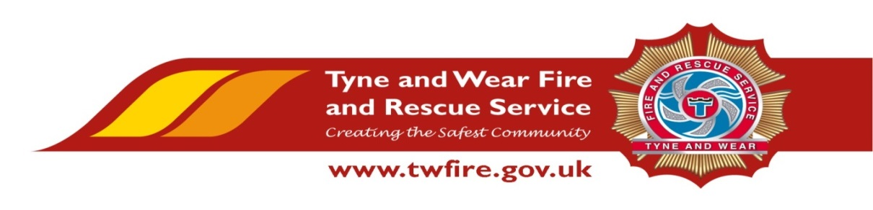

Control of Major Accident Hazards Regulations (COMAH) and Resilience Advisor
Starting salary of £29,636 + Benefits

We have an exciting opportunity for a talented and proactive COMAH/Resilience Advisor.

The Role:

Under the guidance of the Head of Resilience, the successful candidate will be responsible for the creation, maintenance, revision, training and exercising of emergency plans and procedures in accordance with the requirements of the COMAH Regulations 2015, and Pipeline Safety Regulations 1996. The role will involve the production of accurate time keeping records to ensure cost recovery. It will also involve supporting and representing the organisation within the Local Resilience Forum (LRF), the management of Resilience Direct and full involvement with Tyne and Wear Fire and Rescue Service Resilience exercise planning.
The Service values and respects the diversity of its employees, and aims to recruit a workforce that represents the communities we serve. We welcome applications irrespective of people’s race, disability, gender, sexual orientation, religion or belief, age, gender identity, marriage and civil partnership, pregnancy and maternity.
Required Skills/Experience:

- Fully conversant with the Control of Major Accident Hazards Regulations 2015.

- Experience of working in a multi-agency environment and able to communicate effectively with all stakeholders and partners.

- Proven experience in preparing written work to a high standard and in accordance with the relevant legislation.

- Skilled in the areas of emergency planning and major incident management.

What we can offer you

Tyne and Wear Fire and Rescue Service Headquarters are based in a purpose build office in Washington, with ample free parking and easy access from the A1 and A19. On site facilities include catering facilities and an onsite gym. The role also benefits from an attractive package, including up to 22 days holiday and public holidays, Local Government Pension Scheme and access to a range of social and volunteering opportunities.

Closing Date: Friday 31 May 2019 at 12 noon.

Interviews: Week Commencing 03 June 2019.
