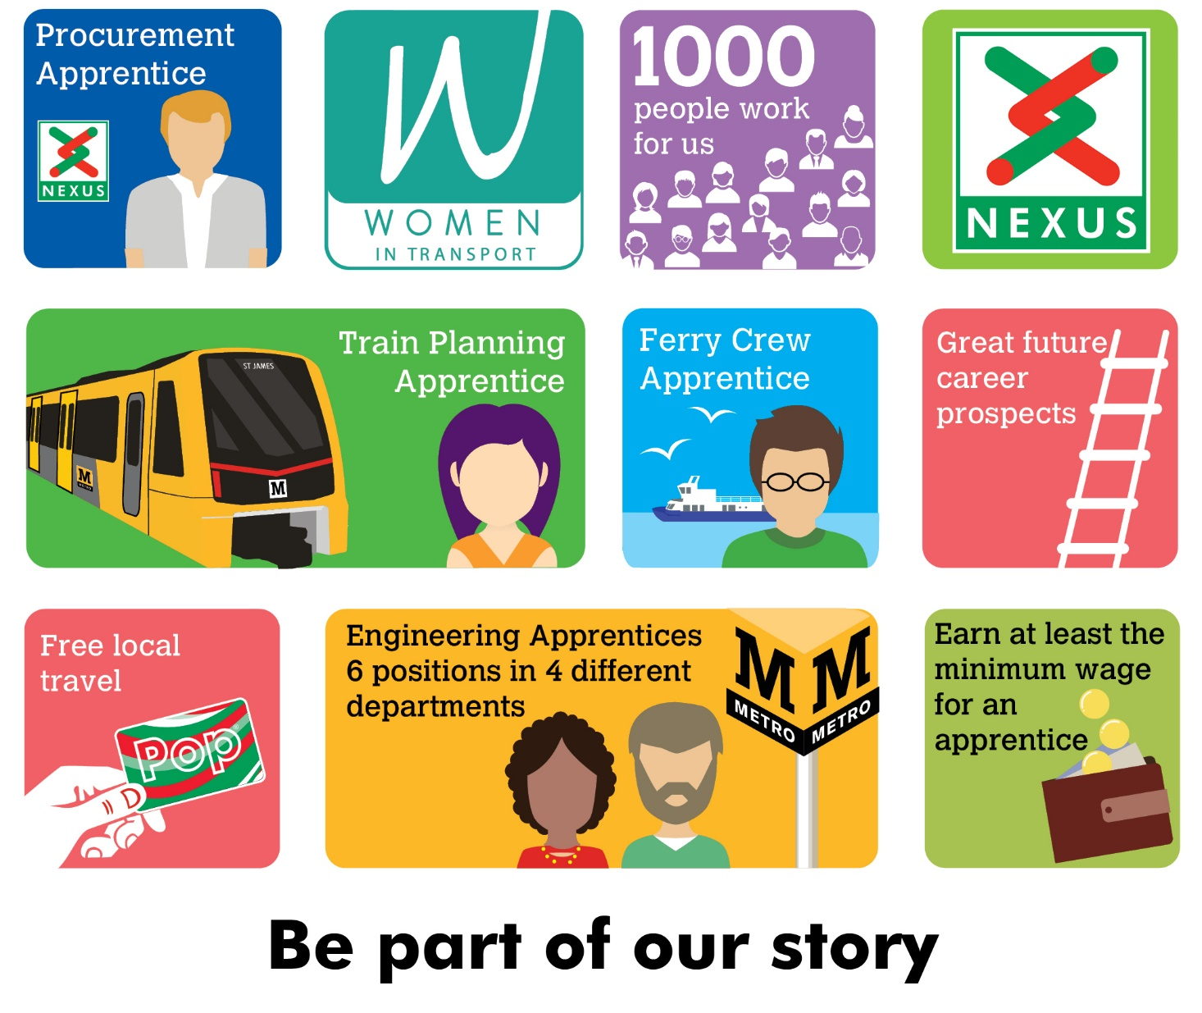
Track Apprentice
Nexus is searching for an Apprentice to join the Track section of the Maintenance Delivery Department.
The successful candidate will learn both at work and at college how to inspect and maintain track infrastructure assets. If successful, you will be part of a team that will work to ensure the track assets are complaint and reliable on the Tyne and Wear Metro’s network. The shift pattern may include night shift.
We are looking for a colleague who has a positive attitude towards learning, rules and procedures, a logical approach towards problem solving and who can remain calm under pressure.
Interviews will be held on 24th June 2022 and alternative dates will not be available.

Salary - Age dependant (not less than Apprentice minimum wage),
plus shift allowance if applicable
Plus, defined benefit pension scheme, free local travel and access to other benefits.
Closing date 5th June 2022

Find out more at nexus.org.uk

