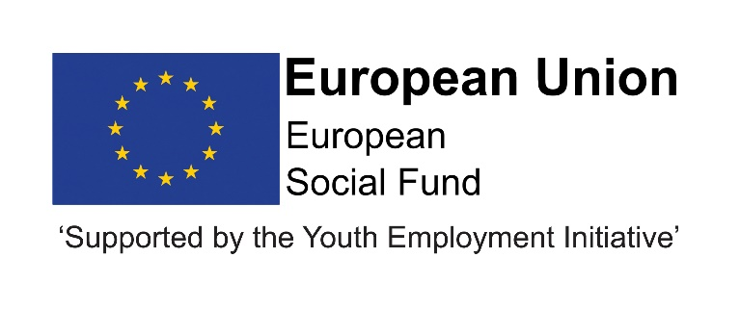

Job Description
Post title | Progression Worker
JE Reference No | N10053
Grade | Grade 6
Service | Children and Young People’s Services
Service Area | Education and Skills; Progression and Learning
Reporting to | Progression Team Leader.
Location | Your normal place of work will be Crook Civic Centre, but you may be required to work at any Council workplace within County Durham.
DBS | This post is subject to an enhanced disclosure.
Flexitime | This post is eligible for flexitime.
Politically restricted | This post is not designated as a politically restricted post in accordance with the requirements of Section 1(5) of the Local Government and Housing Act 1989 and by regulations made from time to time by the Secretary of State.
Relevant to this post | This post is initially funded until July 2021 with the possibility of further extension, dependent upon approval of funding.  This post is funded through ESF and the Youth Employment Initiative (YEI) as part of the 2014-2020 European Structural and Investment Funds Growth Programme in England. The YEI/ESF funding will end in July 2021.

Description of role

The role of Progression Worker is to engage with, and provide support to, young people to enable them to progress into and remain in education, employment or training, as part of their successful transition into adult life. The Progression Worker will work alongside Progression Advisors and in partnership with education and training providers to maximise the potential of young people.

Duties and responsibilities

Listed below are the responsibilities this role will be primarily responsible for:

• To work with young people who are NEET and require additional support e.g. defined vulnerable group;

• To utilise creative approaches in order to engage and maintain contact with harder to reach young people;

• To develop integrated working to ensure targeted groups of young people who are NEET are identified and supported to achieve improved outcomes and progression;

• To manage own caseload, using the Local Authority CCIS (Client Caseload Information System) and other case management systems as appropriate;

• To accurately maintain and update client records using the Local Authority CCIS, including all interventions, follow-ups and destinations, in order to contribute to accurate Management Information;

• To support young people in activities such as job search, CV sessions, job applications and applications to education and training providers;

• To track young people, in order to identify those who require support, in line with procedures;

• To work with other agencies and services in order to provide support to young people;

• To provide practical support to young people in order to tackle their barriers to progression;

• To challenge the attitudes and aspirations of some young people who are NEET, in order to encourage them to develop new perspectives that will support their progression;

• To engage with young people (individually and in small groups) within their communities to deliver/support high quality youth work type activities which build resilience and develop confidence and life skills to improve progression into education, employment or training;

• To identify and nominate suitable young people for vacancies in conjunction with employers, education and training providers;

• To ensure vacancies secured locally are recorded accurately and entered onto the Local Authority CCIS to enable sharing across the Service;

• To establish and maintain positive relationships with education and training providers in locality;

• To engage young people in effective dialogue in order to review and improve Service delivery;

• To ensure effective information sharing in relation to early identification and assessment of need and delivery of support to young people in need of additional support, in order to improve their outcomes;

• To work in the interests of young people through challenging stereotypes and promoting equal opportunities;

• To ensure effective safeguarding and child protection arrangements, in line with Durham County Council policy and guidelines;

• To work in line with Durham County Council policies and procedures;

• To meet own professional development needs by attending appropriate training courses and undertaking self-directed study, as identified through support and supervision, annual appraisal etc.

Organisational responsibilities

- Values and behaviours
To demonstrate and be a role model for the council’s values and behaviours to promote and encourage positive behaviours, enhancing the quality and integrity of the services we provide.

- Smarter working, transformation and design principles
To seek new and innovative ideas to work smarter, irrespective of job role, and to be creative, innovative and empowered. Understand the operational impact of transformational change and service design principles to support new ways of working and to meet customer needs.

- Communication
To communicate effectively with our customers, managers, peers and partners and to work collaboratively to provide the best possible public service. Communication between teams, services and partner organisations is imperative in providing the best possible service to our public.

- Health, Safety and Wellbeing
To take responsibility for health, safety and wellbeing in accordance with the council’s Health and Safety policy and procedures.

- Equality and diversity
To promote a society that gives everyone an equal chance to learn, work and live, free from discrimination and prejudice and ensure our commitment is put into practice. All employees are responsible for eliminating unfair and unlawful discrimination in everything that they do.

- Confidentiality
To work in a way that does not divulge personal and/or confidential information and follow the council’s policies and procedures in relation to data protection and security of information.

- Climate Change
To contribute to our corporate responsibility in relation to climate change by considering and limiting the carbon impact of activities during the course of your work, wherever possible.

- Performance management
To promote a culture whereby performance management is ingrained and the highest of standards and performance are achieved by all. Contribute to the council’s Performance and Development Review processes to ensure continuous learning and improvement and to increase organisational performance.

- Quality assurance (for applicable posts)
To set, monitor and evaluate standards at individual, team and service level so that the highest standards of service are delivered and maintained. Use data, where appropriate, to enhance the quality of service provision and support decision making processes.

- Management and leadership (for applicable posts)
To provide vision and leadership to inspire and empower all employees so they can reach their full potential and contribute to the council’s values and behaviours. Managers and leaders must engage in personal development to ensure they are equipped to lead transformational change; always searching for better ways to do things differently to meet organisational changes and service priorities.

- Financial management (for applicable posts)
To manage a designated budget, ensuring that the service achieves value for money in all circumstances through the monitoring of expenditure and the early identification of any financial irregularity.

The above is not exhaustive and the post holder will be expected to undertake any duties which may reasonably fall within the level of responsibility and the competence of the post as directed by your manager.

Person specification
 | Essential | Desirable
Qualifications | • Level 3 qualification in Information, Advice and Guidance or Youth Work  Or  • Level 2 qualification in either of the above or a relevant subject with a willingness to work towards a Level 3 qualification in Information, Advice and Guidance” | • Counselling qualification.
Experience | • Experience of working with young people who are NEET, their parents/carers and other professionals.  • Experience of providing information, advice, guidance and support to young people.  • Experience of working in partnership with employers, education and training providers.  • Experience of delivering planned interventions that lead to improved outcomes for young people. | • Experience of managing a caseload.  • Experience of planning and delivering group work activities to targeted groups of young people.  • Experience of using client databases to record interventions.
Skills & Knowledge | • Understanding of issues/barriers relating to young people who are NEET and their progression into education, employment or training.  • Knowledge of post-16 learning and career options.  • A person-centred, empathetic and non-judgemental approach to working with young people.  • Ability to communicate effectively with a range of individuals, including parents/carers, employers and colleagues in education, care and health as appropriate.  • Action planning and goal setting skills.  • Ability to use ICT including Outlook and Microsoft Office.  • Good communication and interpersonal skills.  • Good written skills and an ability to produce clear and understandable action plans and reports.  • Good organisational skills.  • Ability to prioritise and manage own workload.  • Effective negotiation skills. | • Knowledge of current local labour market and employer needs.  • Knowledge of agencies and services that are available to support young people who are NEET and require additional support.
Personal Qualities | • Open, friendly and supportive with a genuine interest in supporting young people to progress.  • Hold high aspirations for young people.  • Personal resilience.  • Ability to motivate and support young people, colleagues and partners.  • Commitment to high quality service delivery.  • Adaptability, flexibility and capacity to work effectively under pressure and to tight deadlines.  • Ability to work under direction and to use own initiative when appropriate.  • Ability to work as part of a team making active contributions to support its success.  • Willingness to undertake ongoing professional development.  • Commitment to Equal Opportunities.  • Access to a car or means of mobility support (if driving, must hold a full current UK driving licence and appropriate insurance).  • Willingness to occasionally work unsocial hours as required, including evenings and weekends.

