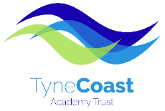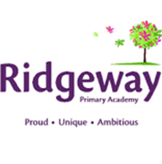

Teaching Assistant – Level 2, 37 hpw (Term Time Only + 5 days)
Ridgeway Primary Academy
Annual pro-rata salary is £19,212 per annum

Required as soon as possible

Do you want to work in a dynamic, exciting team within our energised and vibrant Academy? Are you proud, unique and ambitious?
We are seeking to appoint an enthusiastic and flexible Teaching Assistant to join the team at Ridgeway Primary Academy supporting children in all aspects of school life.

We are an integral school within Tyne Coast Multi Academy Trust which continues to strategically develop providing excellent career development opportunities. We are committed to investing in our staff and you will receive a supportive induction programme. Opportunities are also available for Trust wide working and career development opportunities.

Ridgeway Primary Academy and Tyne Coast Academy Trust are committed to safeguarding and promoting the welfare of children and young people. We expect all staff to share this commitment and to undergo appropriate checks including an enhanced DBS with barred list check.

In line with the guidance in Keeping Children Safe in Education, we will carry out an online search as part of our due diligence on shortlisted candidates.

Application packs and further information can be found on the Tyne Coast Academy Trust website https://www.tynecoastacademytrust.co.uk/join-our-team-current-vacancies/ or by contacting Melissa Dobrianski, Head of HR & Business Operations at mdobrianski@tynecoastacademytrust.co.uk

The deadline for applications is 12pm on Monday 17 April 2023. Please return completed applications to mdobrianski@tynecoastacademytrust.co.uk

Tyne Coast Academy Trust is the Employer, and the role is based at Ridgeway Primary Academy.

