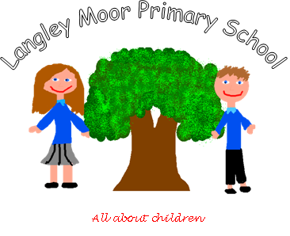
LANGLEY MOOR PRIMARY SCHOOL

COL 14 0.8 Teaching Assistant (with additional responsibility for transition at Key Stage 2-3)

Job Description

Key duties:
- Provide learning activities for individuals and groups of pupils and also under the professional direction and supervision of a qualified teacher, differentiating and adapting learning programmes to suit the needs of allocated pupils
- Assess, record and report on development, progress and attainment as agreed with the teacher
- Monitor and record pupil responses and learning achievements, drawing any problems which cannot be resolved to the attention of the teacher
- Plan and evaluate specialist learning activities with the teacher, writing reports and records as required
- Select and adapt appropriate resources/methods to facilitate agreed learning activities
- Support pupils in social and emotional well-being, reporting problems to the teacher as appropriate
- Provide transition support between a number of primary schools and the secondary school.
- Teaching Assistants in this role are expected to undertake at least one of the following:
  - Provide specialist support to pupils with learning, behavioural, communication, social, sensory or physical difficulties
  - Provide specialist support to pupils where English is not their first language
  - Provide specialist support to gifted and talented pupils
  - Provide high quality transition experiences between feeder primary schools and the secondary school.

Teaching Assistants in this role may also:
- Establish and maintain relationships with families, carers and other adults, e.g. speech therapists
- Supervise the work of other support staff/trainees
- Be responsible for the preparation, maintenance and control of stocks of materials and resources
- Invigilate exams and tests
- Escort and supervise pupils on educational and out of school activities
- Guide and support pupils in their personal, emotional and social development
- Prepare and present displays
- Supervise individuals and groups of pupils throughout the day, including supervision in the classroom, playground and dining areas
- Assist pupils with eating, dressing and hygiene, as required, whilst encouraging independence
- Be involved in planning, organising and implementing individual development plans for pupils (such as Individual educational plans), including attendance at, and contribution to, reviews
- Work with pupils not working to the normal timetable.
- Monitor and manage stock and supplies for the classroom.

Indicative knowledge, skills and experience

- Working at the national occupational standards (NOS) in Supporting Teaching and Learning reflected in the mandatory and relevant optional units of the level 3 NVQ and Level 3 diploma in specialist support for teaching and learning on the Qualification and Credit Framework.
- Demonstrate specialist skills relevant to their role in 8 (a-d) above.
- Knowledge and compliance with policies and procedures relevant to child protection and health and safety.
Valid clean driving licence and own car with business use insurance

