Applicant Pack

Contents

Welcome from the Chief Executive

Welcome from Chair of the Trustees

Candidate Information about Prosper Learning Trust

Information about our schools

Additional Information

How to Apply

Welcome from the Chief Executive Officer

Dear Applicant

To support the delivery of the Trust’s vision, the Trustees of Prosper Learning Trust (PLT) are looking to appoint to the post of Mini Bus Driver.

The successful candidates will be deployed initially at Mary Astell Academy, but will be expected to work at any Prosper Learning Trust site should the need arise.

Prosper Learning Trust (PLT) formed in January 2018 when Newcastle Bridges School became the approved sponsor of Mary Astell Academy (formerly Linhope PRU).

In April 2019 Thomas Bewick School, a special school for pupils with autism joined the Trust. The governors of the school recognised that the values and ethos of PLT resonated with their own philosophies and vision for the education of pupils outside the mainstream sector.

The next exciting step in the growth of PLT was the opening, in September 2020, of Harry Watts Academy, a special free-school in Sunderland. Thomas Bewick School was instrumental in the successful application for this free school and the vision is very much for both schools to work collaboratively together to deliver the best educational practice for pupils with ASD.

The first phase of PLT’s growth plan will conclude with the opening, in September 2023, of Gilbert Ward Academy, a hybrid ASD/SEMH free school, in Blyth. By the time this school opens PLT will operate across three Local Authority areas, educate in the region of 650 pupils and employ around 350 staff.

Everyone within PLT works very hard to ensure that we are providing the highest quality education for all our pupils. The Trustees have a very clear strategic direction of how as a Trust we can grow and develop while balancing all decisions against risk. This strategic direction is captured in a three-year strategic plan which aligns with our vision and which illustrates how we operate according to our values of aspiration, integrity, kindness and resilience.

The appointment to this post is crucial to our development and future plans.

We are looking for an enthusiastic and committed candidate who sees their own values and principles reflected in ours.

Experience of working in a school/academy setting is highly desirable but not essential. The successful candidate will:
- Be expected to demonstrate flexibility and be available to work additional hours to accommodate occasional evening and special events e.g. CPD sessions, meetings
- Be creative and able to problem solve
- Be able to plan for and implement new initiatives
- Have proven skills at managing systems
- Have the ability to manage their time effectively, use initiative and be professional with a flexible attitude.

The Trust offers the successful candidate:
- A friendly and supportive team of staff who are willing to share expertise and learn from one another
- A supportive Trust, Trustees and Governors
- Further professional development appropriate to the role
- The option to join the appropriate pension scheme (TPS or LGPS)

For a confidential and informal conversation to discuss this opportunity please contact Michael Pearson on 0191 2674447

Chris Richardson
Chief Executive Officer

Welcome from Chair of the Trustees

Dear Applicant

Thank you for your interest in joining Prosper Learning Trust. Prosper is a small but growing multi-academy trust, with schools in Newcastle, Sunderland and Northumberland. We work with and support vulnerable learners, aged 3-19, across a number of diverse schools and settings. The Trust is led by a Board of Trustees, who set the strategic direction of the Trust and hold senior leaders to account. Our Board is made up of a strong and committed group of people from a wide range of backgrounds. Each school also has a local advisory committee, which oversees developments at a more local level.

Our Trust wide values identify how we want to work with our pupils, staff and wider community. These values are:

Aspiration

Integrity

Kindness

Resilience

We look to ourselves to model these values and we are committed to embedding them into all relationships, both within and outside the Trust. We also aspire to use these values to inform decision making at individual, school and Trust level, including recruitment of staff.

We are committed to supporting all colleagues in their professional development and really believe that Prosper Learning Trust can offer exciting career development opportunities. If you connect with our values and want to make a positive impact, we would welcome your application.

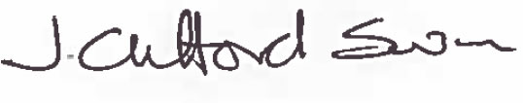

Joanne Clifford Swan
Chair of Trustees
Prosper Learning Trust

Who are Prosper Learning Trust?

Our Trust Vison
Prosper Learning Trust, established in January 2018, is a growing multi academy trust serving children with special education needs and children requiring alternative provision across the North East.

The Trust was formed to help vulnerable young people succeed against the odds. Many children and young people face challenges in their lives that many adults will happily never experience and Prosper is here to support them in doing so. Wherever possible we will help these young people to thrive in a mainstream setting but where that cannot happen we will provide a safe space for them in one of our schools until they are ready to return or move on.

We believe that learning is the key to their chances of success and we will provide the high quality teaching and curriculum they deserve, ensuring an equality of opportunity with their peers in mainstream settings.

Our schools offer children and young people with a diverse range of additional needs, the opportunity to learn in a supportive environment, where differences are celebrated, and every pupil is valued and encouraged to achieve their own potential.

We will deploy our specialist and highly skilled staff and work closely with families, schools and other agencies to create the best possible educational experiences and opportunities for the young people in our care. We will nurture their talent, keep them safe and develop them as people until they are ready to return to mainstream education or move on to adult life as happy, confident and mature young people.

Prosper Learning Trust works across the North East of England and is a champion and advocate for vulnerable young people in our region.

Our Trust Values are:

Prosper Learning Trust is fuelled by ASPIRATION. Predominantly on behalf of the young people we work with and those who love and support them. But also for ourselves; our staff, our community and those who work with us and support our aims and values.
Prosper Learning Trust is an organisation that will act with INTEGRITY at all times. We will do what is best for our young people in every circumstance. We will be fair, open and honest on our dealings with others and will challenge each other every day to live out these values in the workplace, in how we conduct our business and in how we treat each other. We will respect opinion, embrace diversity, work safely and be unrelenting advocates for the wellbeing and character of the young people we care for.
Prosper Learning Trust puts KINDNESS at the heart of everything we do. We understand, we empathise and where necessary, we challenge. We work with young people in a way that helps them to appreciate that looking after one another and mutual support are the way to help everybody succeed and thrive. As an employer we will seek to ensure that staff are valued by treating them with the respect and dignity they deserve.
At Prosper Learning Trust we never give up on children. And we seek to build RESILIENCE in them which means they won’t give up on themselves. Likewise, as an organisation, we will build resilience in our policies, systems and structures to provide stability and longevity in the face of a dynamic and uncertain environment. In order that we can remain a strong and consistent force for good in the lives of the young people and families we work with.
Leadership and Governance
The Board of Prosper Learning Trust has two core functions, which are to set the strategic direction of the organisation and to ensure a robust system of governance.
As a multi-academy trust, the Board of Prosper Learning Trust is responsible for all the academies within the Trust. They do this by delegating functions to the various Trust Committees (Standards, Finance Risk & Audit, Pay & Appraisal) and the Local Advisory Committees of each academy through a scheme of delegation. Our scheme of delegation clarifies the responsibilities and accountability at every level of the organisation. It clarifies the levels of authorisation placed upon the numerous tiers of the Trust Structure, including CEO and Local Advisory Committees. The Board believe that the best results will be achieved through clear lines of accountability.

Governance Structure Diagram
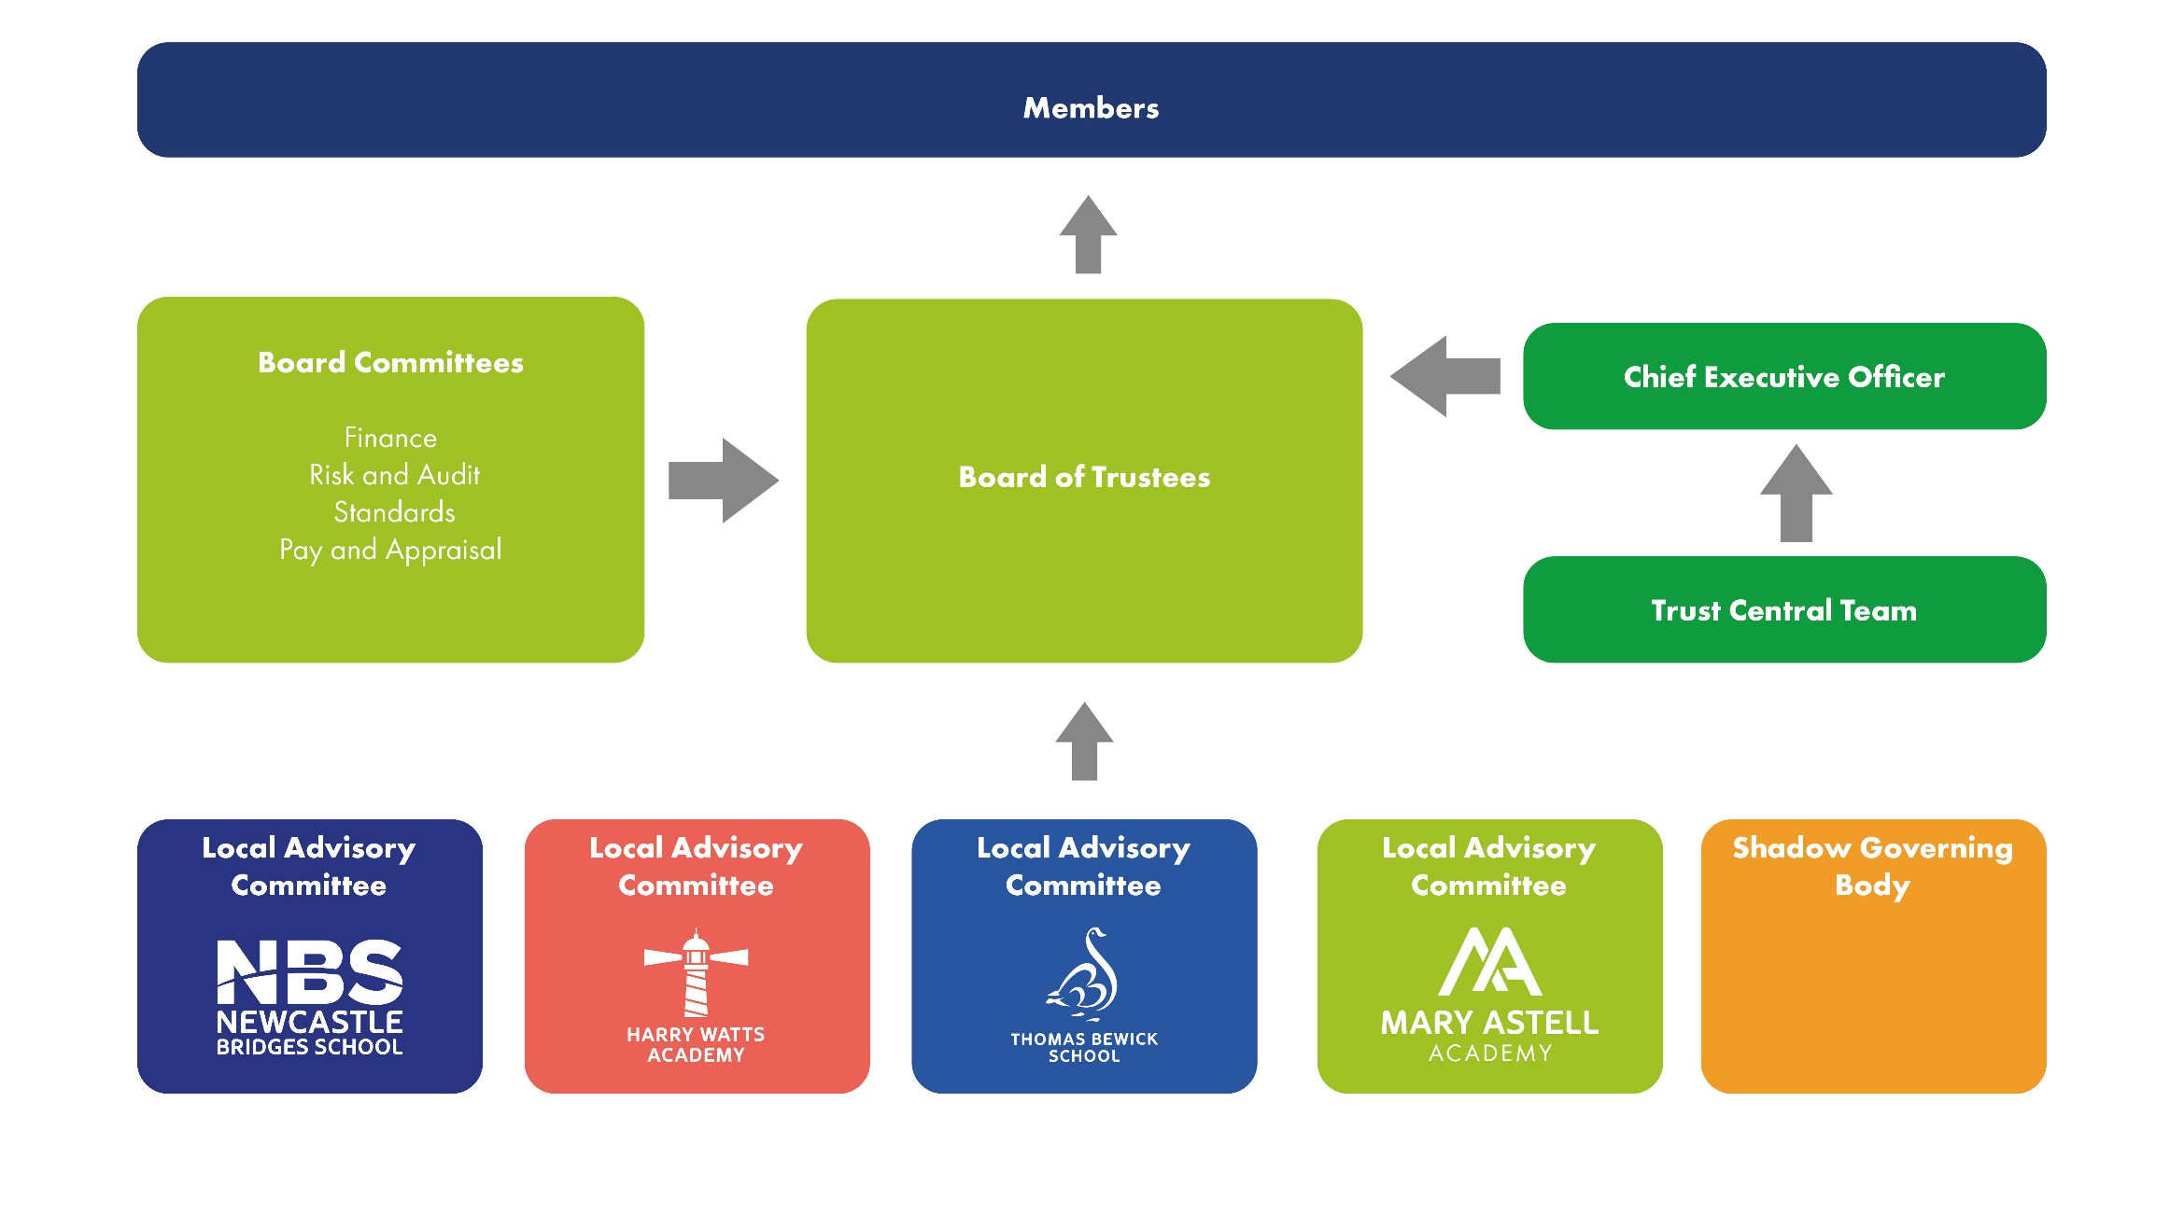

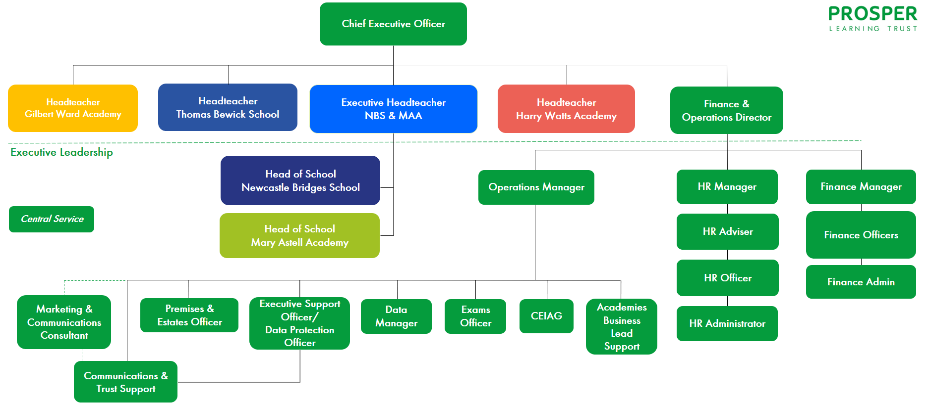
Leadership Diagram

About our schools

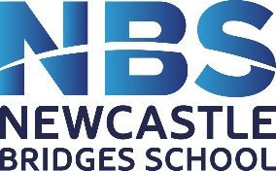

Newcastle Bridges School is a multi-site school for pupils who have medical needs or are not able to access mainstream school because of mental and/or physical health. A number of provisions are based within hospital settings. The school meets a huge variety of complex needs and strives to ensure that its pupils, no matter what difficulties they face, are not disadvantaged in any way with regard to their education and future opportunities. The school provides a holistic, child centred education that encourages pupils to aim high. Every pupil is equal, valued and unique and we aim to provide an environment where all pupils feel safe and can flourish.
The school has various departments, each of which caters for a particular group of pupils and their needs.
The Alnwood Clinic - a mental health clinical setting for 12-18 year olds with mental health needs or an additional learning disability.
Ferndene is a purpose built inpatient centre which provides assessment and treatment for 12-18 year olds with complex mental health, behavioural and emotional needs including pupils with a learning disability.
The Complex Neurodevelopmental Disorder Service (CNDS) is a specialist second opinion service for nursery or primary school aged children who may have Autism Spectrum Disorder (ASD) and other complex communication/mental health/neuro-developmental problems.
The Great North Children’s Hospital (GNCH) caters for pupils whose education is interrupted by regular stays, or a long term stay in hospital. Pupils are taught by a team of teachers in the different specialist paediatric wards or in the hospital classroom.
The Kenton site is a Newcastle Local Authority commissioned provision offering education to pupils 11-16 years old who are unable to access mainstream school due to medical and mental health needs.
Medical Pathway Provision provides education for pupils who are unable to attend their normal place of education due to illness. This service is based within our Kenton site. Pupils are taught from Reception to Year 11 and teaching can take place in a variety of settings within the community as appropriate to their medical needs.

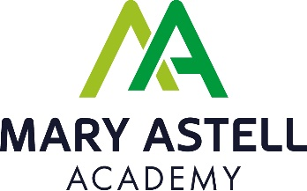

Mary Astell Academy is an AP academy for pupils who have been permanently excluded from mainstream school. The school is based upon values which include giving young people a fresh start and our ultimate aim is to always provide an opportunity to return to mainstream education. In instances where this is not possible, we continually endeavour to provide a curriculum which provides equality of opportunity. Pupils are able access a stimulating and caring learning environment supported by talented and committed staff who put learning and progression at the forefront of everything they do.

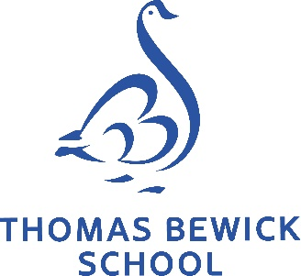

Thomas Bewick School is an all age specialist provision in Newcastle upon Tyne for children and young people with autism (3-19 years), which operates over three different sites. The school offers a broad and balanced curriculum with personalised pathways and high quality pastoral care, to meet their individual needs and learning styles. Pupils are supported with autism specific strategies and approaches by highly trained staff to ensure barriers to learning are addressed and all are able to take advantage of learning opportunities.

Harry Watts Academy is a specialist school for up to 140 children with autism aged 5-16 based in the city of Sunderland. The school opened in September 2020, with the aim to become a recognised centre of excellence both locally and nationally. From September 2022 the school will be based over two sites. A broad and balanced curriculum with personalised pathways and specialised teaching inspires pupils to learning success, supported with high quality pastoral care. The school’s main priority will be to address the autism-specific barriers to learning so that our pupils are able to take advantage of learning opportunities.

Candidate Information

Prosper Learning Trust is committed to safeguarding and promoting the welfare of children and expects all staff and volunteers to share this commitment.

1. Contact Details

Address: Prosper Learning Trust, Linhope Road, West Denton, Newcastle
upon Tyne, NE5 2LW

Phone: 0191 605 3899
E-mail: HRadmin@prosperlearningtrust.co.uk
Website: www.prosperlearningtrust.co.uk

2. Staff

MAT Support: Chief Executive Officer
Finance & Operations Director
Trust Operations Manager & Central Operations Team
HR Manager & HR Team
Finance Manager & Finance Team

3. Academy Information

Mary Astell Academy
Number on roll: 80

Location: The school is located in West Denton in the West of Newcastle
upon Tyne. This is a residential area and the school is located
close to a primary school, a secondary school, a special academy (part
of Prosper Learning Trust) and a shopping centre. The area is well
connected locally by road.

Newcastle Bridges School
Number on roll: 99

Location: The main school is located in Kenton, in the West of Newcastle upon Tyne. This is a residential area and the school is located on the same site as Kenton School, and shares a building with Prosper Learning Trust, a Nursery provider, Clennell Education Solutions and Robertson Facilities Management. The area is well connected locally by road.

Thomas Bewick School
Number on roll: 316

Location: The school is located in the West of Newcastle upon Tyne. The school is based on three sites – Early Years at Broadwood Primary School, Site 1 on Linhope Road in West Denton and Site 2 sharing a site with Studio West in West Denton. These are all residential areas and the school is located close to primary schools, a secondary school, an alternative provision academy (part of Prosper Learning Trust) and a shopping centre. The area is well connected locally by road.

Harry Watts Academy
Number on roll: 140

Location: The school is located in Sunderland and is based over two sites. Site 1
at Hylton Redhouse and Site 2 at Harraton, Washington. Both sites are
residential areas.

Gilbert Ward Academy (due to open September 2023)
Number on roll (when full): 80

Location: The academy will be located in Blyth in a residential area, close to a local primary school and the leisure centre.

Further Information about the schools is available on our website
www.prosperlearningtrust.co.uk

Living in the North East

The North East is an exciting and vibrant place to live and work:

- In recent years there has been a great deal of investment and regeneration, not just by local improvements such as better play areas, but real investment by some big-name companies in tech, financial services and manufacturing. Many town and city centres are being modernised and new houses being built. Quaysides are being revamped into leisure hot spots with some very desirable apartments.

- Many sectors of the digital industry are moving to, or have moved to, the North East. And companies such as Nissan have created tens of thousands of jobs in the area. Scientific research, chemical processing, printable electronics, distribution, and of course tourism, are all major employers in the North East.

- From the Northumberland Coast to the North Pennines, Keilder Forest and Park, to Durham Heritage Coast, and Hadrians Wall, to Whitley Bay, there are some beautiful places to spend your leisure time. Across the North-East there are golden sandy beaches, award winning parks and gardens and serene countryside within a 15 minute drive of any city centre.

- The North East of England has housing that caters to all budgets and has some of the cheapest property to be found anywhere in the UK. The average house price in June 2019 was £131,000 but prices vary across the area.

- People from the North East are incredibly friendly and helpful. In fact, complete strangers will even talk to you, something that you may find strange and a little unsettling if you come from London. But the locals are rightfully incredibly proud of their heritage and culture and will welcome you with open arms if you make the effort to integrate into the local community.

- The area is well served with transport links, with easy access to London via the motorway and rail services and there are several airports within the region with flights within the UK and beyond.

How to Apply

Applications
Candidates should submit applications on the application form, available on the website and also complete any other requested documentation.

In order to comply with the safer recruitment requirements candidates must fully complete the application form including the section on references. It is not acceptable to substitute parts of the form with your own version. All gaps in employment should be accounted for and explained – these could be further explored in an interview.

References
Open testimonials are not required or accepted for this post, the Trust will take up a professional reference from your existing employer and one other of your choice. This reference will be requested if you are shortlisted for interview. If you are not currently working with children, references will be requested from previous employers where this was the case.

Interviews
Shortlisted candidates will be invited to interview by letter or email. Interviews will take place as specified in the communication. The interview will include a mix of formal and informal selection procedures.

Return Applications
Please return application forms to: HRadmin@prosperlearningtrust.co.uk or by post to HR Admin, Prosper Learning Trust, ​C/O Newcastle Bridges School, Drayton Road, Newcastle upon Tyne NE3 3RU.
(Please mark your application “Private and Confidential”)

