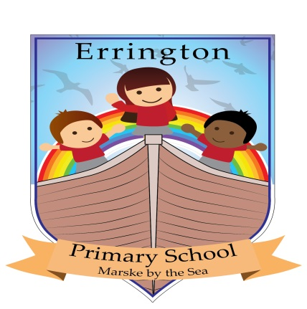
Letter to Candidates
Dear Candidate,
We are a welcoming, friendly school who are proud of our successes and achievements of all children in our care. Our children enjoy their learning through an innovative and creative curriculum and we provide many opportunities for excellent progress to occur. We strive to meet the needs of all children and ensure we have a warm, happy environment in which children can experience new learning, feeling confident and safe.
We feel that children come to school to learn, develop skills for life and experience exciting opportunities to make them confident in applying themselves and achieve more.
We are proud of our community, parents and governors. We feel a great achievement for our school is our strong welcoming ethos, which we promote continuously. We have close links to home, school and the surrounding area. All visitors in school comment on the happy atmosphere, interaction and involvement of children in their learning. Our children are stimulated, enthused and motivated by a high standard of teaching and learning from nursery through to year 6.
Everyone is welcome and invited to events in school from open days, special events through the year, lunches, learning mornings and afternoons. As a school we encourage people to be involved in the learning of our children at all stages and offer support and displays of work so that people feel a part of our community.
We keep people informed through newsletters, webpages, exhibited work and displays and encourage parents to offer suggestions and open discussions about school, progress in school and further opportunities to move forward.
Every child is unique at Errington Primary and brings something special to our school, which we develop and enhance so that everyone succeeds and has the confidence to shine.
Mrs Sharon Robertson
Headteacher

