St. Anne’s CE Primary and Nursery School 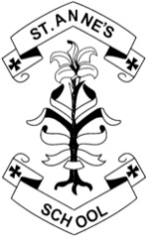

Teaching Assistant (Upper Key Stage 2)

Person Specification

Category | Essential | Desirable
Application | Fully supported in references  Well-structured letter
Qualifications | Minimum NVQ Level 3 in Supporting Teaching and Learning | Current First Aid Certificate  Evidence of further study or qualifications
Experience and knowledge | Demonstrate high standards of working with young children in a teaching and learning capacity.  Experience of observing, monitoring, assessing and maintaining records  Understanding of child development  Knowledge of health and safety and safeguarding procedures | Experience of the Upper Key Stage 2 currculum  Working with children with a range of special educational needs

Category | Essential | Desirable
Skills | Relate well to children, colleagues and parents  Good communication skills  Organised  Ability to work as part of a team as well as under own initiative  Ability to prioritise
Personal attributes | Cheerful and motivated  A good sense of humour  Demonstrate a caring attitude towards children and parents  High personal and professional standards  Flexible approach to the role  Fully supportive of the school’s Christian ethos

