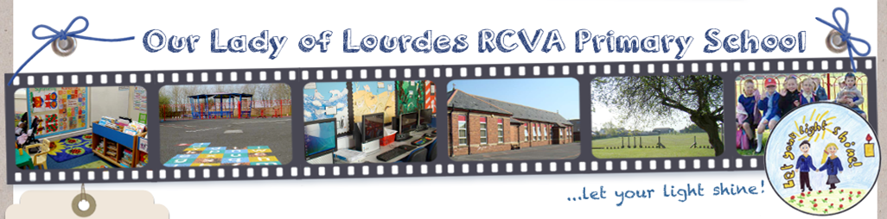

Job Description – Our Lady of Lourdes R.C. Primary School

Post Title: Class Teacher Full Time (Permanent)

Grade: Main Scale 1- 6 /UPS

Responsible to: Headteacher and Leadership Team

The key responsibilities of the post are to:

- Take responsibility for a class of pupils as directed by the Headteacher.

- Support the Catholic life and ethos of the school.

- Direct and deploy other staff or volunteers as required.

- Carry out other duties or responsibilities as required by the Headteacher or Senior Management Team, which contribute to the smooth running of the class, or the school as a whole.

The generic duties of the post are based on the Teachers’ Standards:

The post holder must:

1 Set high expectations which inspire, motivate and challenge pupils

- establish a safe and stimulating environment for pupils, rooted in mutual respect
- set goals that stretch and challenge pupils of all backgrounds, abilities and dispositions
- demonstrate consistently positive attitudes, values and behaviour.

2 Promote good progress and outcomes by pupils

- be accountable for pupils’ attainment, progress and outcomes
- be aware of pupils’ capabilities and their prior knowledge, and plan teaching to build on these
- guide pupils to reflect on the progress they have made and their emerging needs
- demonstrate knowledge and understanding of how pupils learn and how this impacts on teaching
- encourage pupils to take a responsible and conscientious attitude to their own work and study.

3 Demonstrate good subject and curriculum knowledge

- have a secure knowledge of the relevant subject(s) and curriculum areas, foster and maintain pupils’ interest in the subject, and address misunderstandings
- demonstrate a critical understanding of developments in the subject and curriculum areas, and promote the value of scholarship
- demonstrate an understanding of and take responsibility for promoting high standards of literacy, articulacy and the correct use of standard English, whatever the teacher’s specialist subject
- if teaching early reading, demonstrate a clear understanding of systematic synthetic phonics
- if teaching early mathematics, demonstrate a clear understanding of appropriate teaching strategies.

4 Plan and teach well-structured lessons

- impart knowledge and develop understanding through effective use of lesson time
- promote a love of learning and children’s intellectual curiosity
- set homework and plan other out-of-class activities to consolidate and extend the knowledge and understanding pupils have acquired
- reflect systematically on the effectiveness of lessons and approaches to teaching
- contribute to the design and provision of an engaging curriculum within the relevant subject area(s).

5 Adapt teaching to respond to the strengths and needs of all pupils

- know when and how to differentiate appropriately, using approaches which enable pupils to be taught effectively
- have a secure understanding of how a range of factors can inhibit pupils’ ability to learn, and how best to overcome these
- demonstrate an awareness of the physical, social and intellectual development of children, and know how to adapt teaching to support pupils’ education at different stages of development
- have a clear understanding of the needs of all pupils, including those with special educational needs; those of high ability; those with English as an additional language; those with disabilities; and be able to use and evaluate distinctive teaching approaches to engage and support them.

6 Make accurate and productive use of assessment

- know and understand how to assess the relevant subject and curriculum areas, including statutory assessment requirements
- make use of formative and summative assessment to secure pupils’ progress
- use relevant data to monitor progress, set targets, and plan subsequent lessons
- give pupils regular feedback, both orally and through accurate marking, and encourage pupils to respond to the feedback.

7 Manage behaviour effectively to ensure a good and safe learning environment

- have clear rules and routines for behaviour in classrooms, and take responsibility for promoting good and courteous behaviour both in classrooms and around the school, in accordance with the school’s behaviour policy.
- Have high expectations of behaviour, and establish a framework for discipline with a range of strategies, using praise, sanctions and rewards consistently and fairly
- manage classes effectively, using approaches which are appropriate to pupils’ needs in order to involve and motivate them
- maintain good relationships with pupils, exercise appropriate authority, and act decisively when necessary.

8 Fulfil wider professional responsibilities

- make a positive contribution to the wider life and ethos of the school
- develop effective professional relationships with colleagues, knowing how and when to draw on advice and specialist support
- deploy support staff effectively
- take responsibility for improving teaching through appropriate professional development, responding to advice and feedback from colleagues
- communicate effectively with parents with regard to pupils’ achievements and well-being.

Common Duties and Responsibilities:

Professional Practice
To ensure that professional practice in the school is carried out to the highest standards and developed in line with the school’s stated objectives of continual improvement in quality of its service to internal and external customers.

Health and Safety
To ensure that the Health and Safety policy and procedures are understood, implemented and monitored.

Appraisal
All members of staff will receive appraisals and it is the responsibility of each member of staff to follow guidance on the appraisal process.

Equality and Diversity
To ensure our commitment is put into practice we have an equality policy which includes responsibility for all staff to eliminate unfair and unlawful discrimination, advance equality of opportunity for all and foster good relations.

Confidentiality
All members of staff are required to undertake that they will not divulge to anyone personal and/or confidential information to which they may have access during the course of their work.

All members of staff must be aware that they have explicit responsibility for the confidentiality and security of information received and imported in the course of work and using school information assets.

Safer Recruitment
This organization is committed to safeguarding and promoting the welfare of children and young people and expects all staff and volunteers to share this commitment.

*************************

