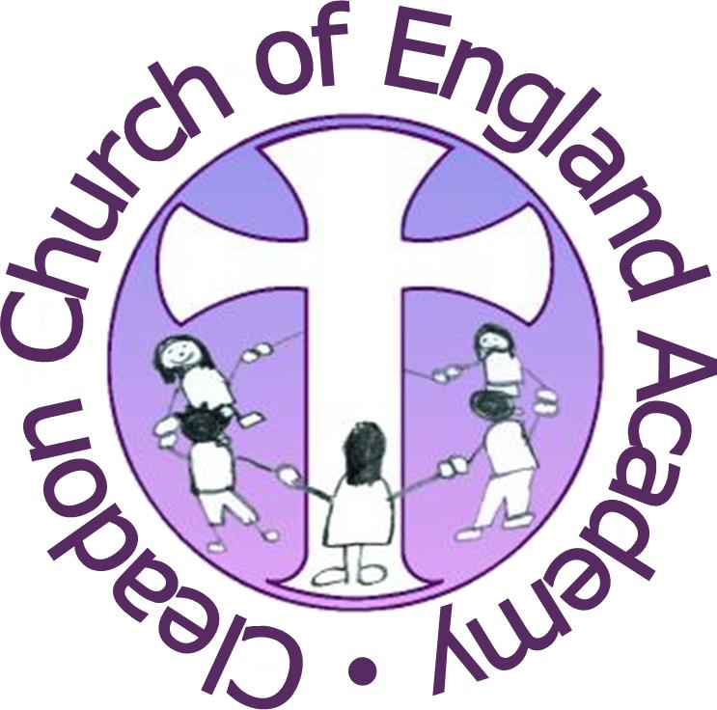

Cleadon Church of England Academy
Job Description

Post Title: Wrap Around Care Assistant- Cleadon Owls
Salary: Band 3 point 3
Employed by: All Saints’ Academies Trust
Line Manager: Wrap Around Care Manager / Headteacher
Location: Cleadon Church of England Academy
Hours: 7:00 – 9:00 & 15:00-18:00 Monday to Friday during school term + School Holiday Cover
Main Purpose of Job
To assist in the smooth running of the Wrap Around Care Provision. To ensure a high quality provision of healthy food and varied activities for pupils to enjoy in a relaxed and calm environment.
Duties and Responsibilities
- To adhere to the Academies Code of Conduct.
- To safeguard children and ensure and promote their health and safety.
- To maintain the healthy eating policy and keep updated with any new information.
- To assist with purchasing food and monitoring stock control.
- To ensure all workspace, cupboards and fridges are cleaned after use.
- To assist with the setting up of areas before children arrive and pack away at the end of each session.
- To assist in planning and coordinating activities and games to interest and stimulate the children.
- To organise the space and resources to create a welcoming, relaxed and informal environment.
- To meet and greet parents and children as they arrive ensuring a positive relationship is built.
- To establish supportive relationships with pupils concerned and to encourage inclusion and good behaviour.
- To note any information passed on from parents and pass onto relevant professionals.
- To serve breakfast / tea to the children encouraging independence or to help others.
- To interact with children, support and model appropriate behaviour.
- To monitor behaviour and ensure the school’s behaviour policy is being followed.
- To administer minor first aid treatments, keep records and assist pupils when unwell.
- To be aware of confidential issues linked to home / pupil / teacher / school work and to ensure confidentiality of such sensitive information.
- To remain aware and work within all relevant school working practices, policies and procedures.
- To attend staff meetings, CPD and school-based INSET as required.
- To be aware of and work in accordance with the school’s safeguarding policies and procedures raising concerns when necessary.
- To undertake other duties appropriate with the grading of the post as required.
Cleadon Church of England Academy is your employer.

PERSON SPECIFICATION - WRAP AROUND CARE ASSISTANT
Requirements | Essential | Desirable
Previous experience of working with children aged 3-11 years old | X
Previous experience of working in a Primary School |  | X
At least 5 A*- C GCSE English and Maths or equivalent | X
NVQ Level 2 or equivalent childcare qualification | X
Good level of Literacy and Numeracy skills | X
Willing to attend training sessions relevant to the job role | X
Paediatric First Aid Certificate (Achieved or working towards) |  | X
Food hygiene certificate |  | X
Health and Safety qualification |  | X
Good organisational skills | X
Good communication skills | X
Knowledge of current issues relevant to education |  | X
Able to work as part of a team and use own initiative | X
Ability to liaise with staff, parents and children | X
A Flexible approach to working hours | X

