Administration Assistant

Grade 4 £17,072 - £17,772 per annum
37 hours per week, Monday - Friday
The Service is seeking to appoint a suitably qualified, enthusiastic and self-motivated administration assistant for a position in our community risk management section based at Fire and Rescue Service HQ at Belmont Business Park, Belmont, Durham.

This post will require the post holder to work from multiple sites within the Service area.

The post holder operates within a framework provided by the service’s community plan, policies, procedures and financial regulations. On a day-to day basis, the post holder is responsible for providing general administration support to the community risk management section and be an administrator to several IT software applications utilised within the Service.

The applicant must hold a qualification in business administration to a minimum NVQ level 3 or equivalent and desirably a level 2 qualification in customer service. Previous experience in general office administration duties and experience of working with various computerised software systems is essential.

Preferable skills and experience required:

- Significant experience in general office administration duties
- Experience of working with various computerised software systems is essential.
- Good interpersonal and communication skills
- Commitment to teamwork and flexibility.

In return the post offers 26 days annual leave rising to 31 days after 5 years, provision of uniform and work ware, sports facilities, car parking and a pension scheme.

For further information please contact Andy Bennett on 0191 375 5680 or 07766 785315. Application packs are available to download via the Northeast Jobs portal www.northeastjobs.org.uk and should be submitted to abennett@ddfire.gov.uk.

CLOSING DATE: Monday 19 February 2018 at 09.00hrs
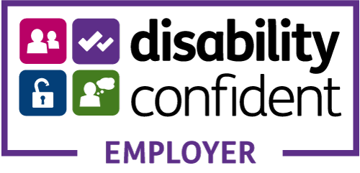 | 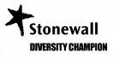 | 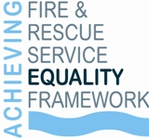
County Durham and Darlington Fire and Rescue Service aims to be an Equal Opportunities Employer and welcomes applications from under-represented groups.
Application details are available in large type, Braille, audio tape and via email. A Minicom facility is available on 0191 3847840. Disabled applicants who meet the essential criteria are guaranteed an interview.

