Living & Working in Northumberland

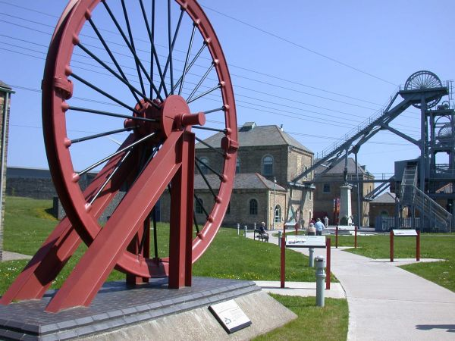
Ashington is one of the largest towns in Northumberland with a population of around 28,000. It grew from a few farms in the early 19th Century to a large coal mining village when the colliery opened in 1867. A lot of the older properties in Ashington are terraced dwellings in long terraced ‘colliery rows’. Ashington was once known as “the largest mining village in the world” but despite this, the last colliery was closed in 1988. Ashington is proud of its history which is remembered at the nearby Woodhorn Museum.
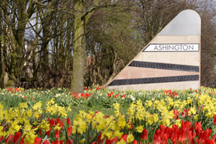

Ashington is also famous for producing some of England’s most outstanding sportsmen, including footballers Jackie Milburn, Jack Charlton and Sir Bobby Charlton, golfer Kenneth Ferrie and cricketers Steve and Ben Harmison and Mark Wood. Ashington is also the birth place of businessman Sir John Hall, soprano Dr Sheila Armstrong and MP Ian Lavery.

Ashington has excellent road links onto the A189 and A1 and regular, reliable bus links which makes commuting easy. Newcastle City Centre is only 20 minutes away.

Newcastle, an inspirational city on the banks of the iconic River Tyne. A city famed for the friendliness of ‘Geordie’ people and its world famous nightlife. There are a huge range of shops in the town centre and at the famous Metro Centre, there is a metro train system, excellent bus and train links, an airport, hundreds of restaurants, music venues to suit all tastes, museums. It is a short journey to the stunning scenery and attractions of the Tyneside coast with Whitley Bay and Tynemouth.

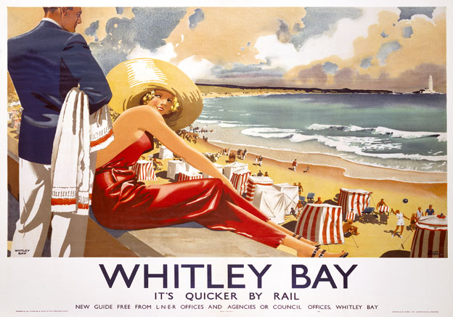

Is Northumberland the best place in the UK to raise a family?

Affordable house prices, low crime rate, good schools, shops and commutability make the county incredibly appealing, says Caroline McGhie of The Telegraph (24/11/14).

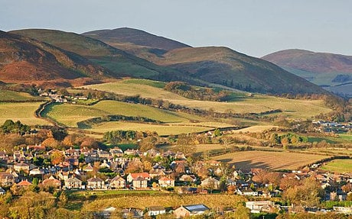
In a recent survey of best places to live in England and Wales, it ranked highly for its affordable house prices, low crime rate, good schools, shops and commutability to Newcastle-upon-Tyne. It is close to the National Park and the magnificent coastline.

It may be far from London’s pressures, but many move here and commute back to the capital to work. “Quite a few do it,” says Sam. “They catch the 7am train from Newcastle and arrive in London Kings Cross by 9.40. Then they catch the train back on Thursday afternoon and work from home on Fridays. Proper countryside, good schools, old-fashioned market towns and windswept coastland is what they come for. Some love the sport – turning out on a cold Sunday morning to hunt, shoot or fish”.

The Romans, when they built Hadrian’s Wall, didn’t really appreciate the countryside, the dry stone walls and the multitude of sheep. Today it has a rarity value augmented by a new appreciation of the night sky. Northumberland International Dark Sky Park was created in 2013. People can visit the Kielder Observatory to see the Milky Way, the galaxies, shooting stars and comets in true darkness.
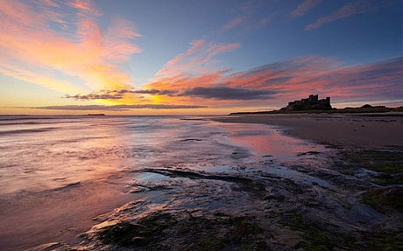

The UK is a very diverse place, and the quality of life you can get in different cities and regions can vary quite a lot. This means if you are looking for the best place to move to in the UK, there are quite a lot of factors you might want to take into account. To help determine the best and worst places to live right now in the United Kingdom, uSwitch's Best Places to Live in The UK Quality of Life Index 2015 has analysed a wide range of different data relating to 138 different locations, and found the places that are statistically the best and worst in terms of things like cost of living, employment prospects, income, and other things like the cost of insurance and how good important things like mobile phone network coverage and broadband speeds are.
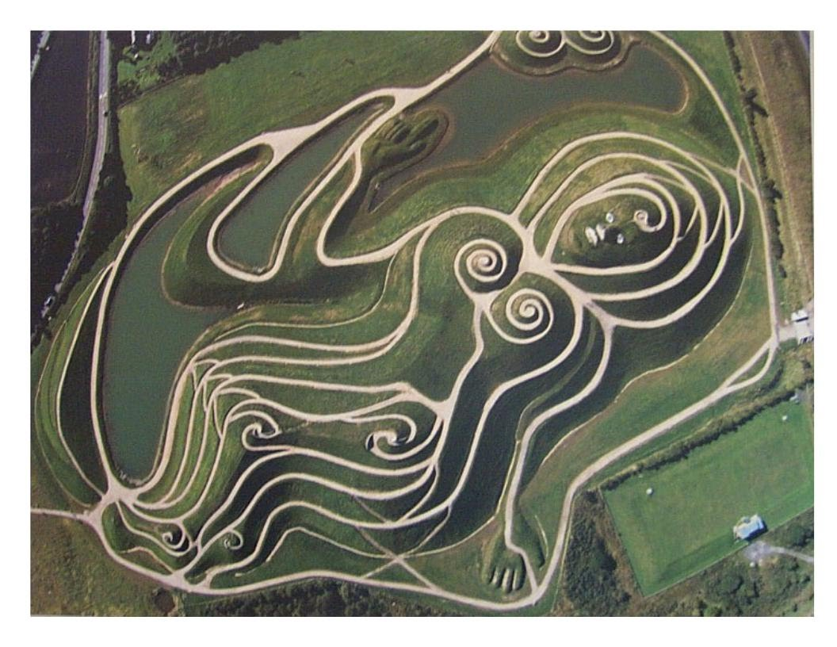
In this study, Northumberland has been ranked as the 4th best place to live in the UK.

Employment
Northumberland has a high rate of employment compared with the national average. 73% of people here are employed, which is even 1% higher than in our number one city of Edinburgh.
45% of people are working between 35 and 45 hours a week, considered to be good, standard full time hours, with a low 22% going over 45 hours per week – indicating a good balance between work and home life for Northumberland's full time employees.

Income
Gross weekly income in Northumberland is actually the lowest of all of our top 10 best places to live in the UK at £447.50 per week, however households still have on average £17.6k in disposable income per year.

House Prices
House prices in Northumberland are far lower than the three regions that rank above it in our top 10, at £147,064 on average. Compared with £293,344 in third place Hertfordshire and it is easy to see how the lower income is offset for many people. Rent is also very low compared with other regions and the national average, at just £57.19 per week.

Home values in Northumberland
 | Avg values | 1 yr
All homes | £189,820 | +0.81%
Detached | £303,417 | -3.29%
Semi | £160,215 | -3.61%
Terraced | £131,895 | +1.27%
Flats | £114,332 | +0.29%

Life Expectancy
Life expectancy is 79 for men and 82 for women, which is among the lowest in the top 10 but still represents 'a good innings' for the people of Northumberland.
Life expectancy is an influential factor that insurance companies use to determine life insurance premiums.

Living Costs
Insurance premiums are very low in Northumberland, with home insurance averaging at just £208 and car insurance at £395.20. With household food bills at just £48.60 per week and petrol prices also low at 116.67p, money can go a long way in this part of the country.

Other Important Factors
Northumberland benefits from very low prices on things that matter like housing and food, meaning you can get a good quality of life thanks to great value for money.

