Durham Trinity School & Sports College
Additional information for the Clerical Assistant vacancy
We have moved in to our new school
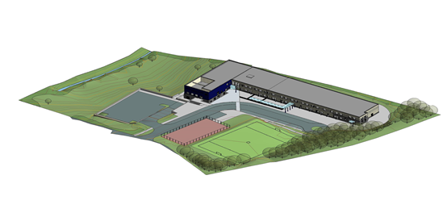
Would you like to teach in this purpose built environment? If so, read on.
The new school building opened after half term in November 2014.
It has brought together the 3 sites of the school together in 1 building.
Our new school building accommodates:
- Nursery, KS1 & KS2 classes, all ages of specialist ASD provision, all ages of sensory provision on the ground floor. Each class has direct access to their outdoor learning space.
- Secondary pupils and Post 16 pupils on the first floor. Specialist teaching rooms are located on this floor.
There are 2 dining areas on the ground floor. One is used by primary pupils and the other by secondary pupils. The multi-purpose hall is timetabled for PE lessons throughout school.
The design of the building has embraced the gradient of the site and there is a small lower ground floor area. The small swimming pool is located on this level along with a variety of rooms for professionals, visiting and school based staff.
Externally there will be a MUGA and sports field. The sports field will be operational from April 2016 after the Flambard school building has been demolished and the seed sown. There is also a grassed area for pupil use below the building and car park.
We are a popular school. Currently there are 202 pupils on roll. Over time this will rise to 220.
The school website www.durhamtrinity.durham.sch.uk has further information about different aspects of school life.

