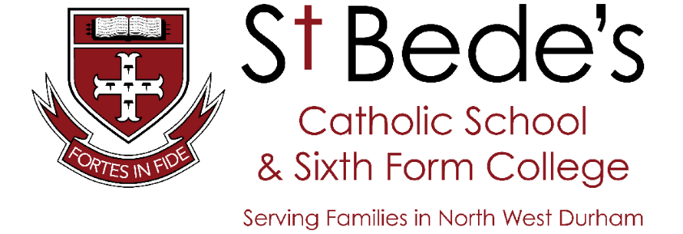

Headteacher: Mr Neville Harrison

Nor 1505 (inc 347 Post 16)

“St. Bede’s is welcoming and inclusive; all students flourish and achieve outstandingly well.”

TEACHER OF ENGLISH
MPS/UPS
1 year initially

Required for September 2015

The Governors seek to appoint an enthusiastic teacher of English, who has the knowledge to enhance student learning in this well-established, successful department. St. Bede’s achieved outstanding results in 2014 with a 100% pass rate at A level and 75% A*-C including English and Maths at GCSE. The successful candidate will teach across the Key Stages.

We provide:

- excellent care and support for all staff;
- comprehensive induction and ongoing opportunities for professional development;
- a positive and stimulating school climate which values the contribution of all staff.

St. Bede’s is a highly successful, oversubscribed, outstanding Teaching School, located within easy travelling distance of Durham, Newcastle and Sunderland.

For an information pack and application form, please visit our school website.

Closing date for completed applications is 12 noon, Friday 6th February 2015
Interviews will be held during the week commencing Monday 9th February 2015

St Bede’s Catholic School & Sixth Form College is committed to safeguarding and promoting the welfare of children and young people and expects all staff and volunteers to share this commitment. Any offer of employment is subject to an enhanced Disclosure and Barring Service check.

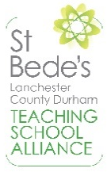
Consett Road
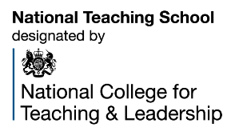
Lanchester
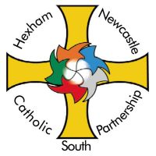
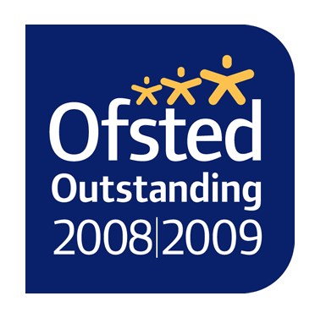
County Durham
DH7 0RD
t 01207 520424
w www.stbedes.durham.sch.uk
e stbedes@stbedes.durham.sch.uk

