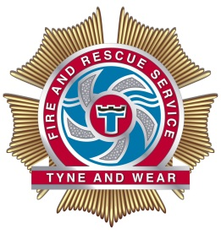
INTER SERVICE TRANSFER
WHOLETIME
FIREFIGHTER AND CREW MANAGERS
SERVICE DELIVERY
Tyne and Wear Fire and Rescue Service are currently seeking Wholetime personnel interested in transferring as Wholetime, substantive in role Competent Firefighters and Crew Managers.

Following our most recent inspection, Her Majesty’s Inspectorate for Constabulary and Fire and Rescue Services graded our culture, training and how we treat our people as ‘Good’ across all three pillars. We are committed to delivering an inclusive, modern and effective service, with staff who reflect the community we serve to deliver a high quality service and contribute to our Vision of ‘Creating the safest community’. We welcome applications irrespective of people’s race, disability, gender, sexual orientation, religion or belief, age, gender identity, marriage and civil partnership, pregnancy and maternity.

As part of your ongoing development you will engage in a continuous programme based around practical and theoretical training to ensure you are provided with the knowledge, skills and understanding to perform your role safely and effectively. Our Service Training Centre offers an exceptionally high level of training and development using state of the art equipment and facilities. We also offer a range of staff benefits and run an active sports and welfare section.

Eligibility Criteria

Firefighter
Applications are invited from Wholetime, substantive in role competent Firefighters currently employed in a UK Fire and Rescue Service.
Crew Manager
Applications are invited from Wholetime, substantive in role competent Crew Managers currently employed in a UK Fire and Rescue Service, and you hold a Level 1 Incident Command Validation which will be validated as part of the assessment.
Please note we welcome applications from Watch Managers however you would be required to undertake the role of Crew Manager should you be successful.

Application Process
If you are interested in applying for these roles, please use this link for the application details. All candidates will be communicated with via e-mail for all parts of the process.
Process | Date
Applications submitted by | 18 October 2019, 12 noon
Physical, Written Assessments, Interview and Medical Assessments | 24 October – 4 November 2019
Training Course | 9 - 20 December 2019
Fully Operational | 23 December 2019
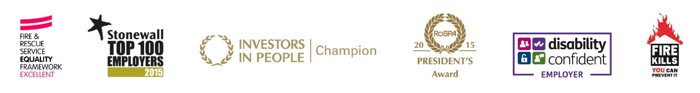
*Dates may be subject to change as required

