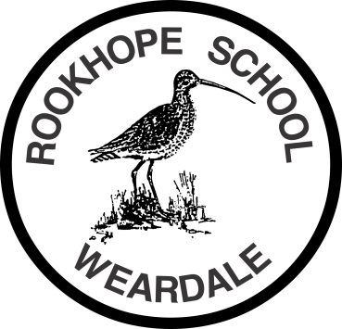

Rookhope Primary School
Safer Recruitment Statement
Rookhope Primary School and Durham County Council are committed to safeguarding and promoting the welfare of all children and young people, and expect all staff and volunteers to share this commitment.

Applicants are advised that:

- When applying, you must provide a full employment history, including periods of unemployment, with dates (to the nearest month) and the names and addresses of previous employers. Any gaps in employment will be explored.

- All references will be applied for in writing prior to interview and referees will be contacted to verify their authenticity. A reference pro-forma will be used without exception meaning that open or letter references will not be accepted.

- Rookhope Primary School and Durham County Council reserve the right to contact your present employer and any previous employer.

- Candidates will be asked about disciplinary offences, including those which have expired alongside any safeguarding concerns.

- The post for which you are applying is exempt under the Rehabilitation of Offenders Act, so all criminal convictions must be stated, with dates. Failure to do so will disqualify the candidate from the appointment and, if appointed, may render the individual liable to immediate dismissal without notice.

- If successful in the selection process, you should be aware that you will be required to undergo an enhanced check carried out by the Disclosure and Barring Service to identify that you are a suitable person to work with children. Further checks will be made at regular intervals thereafter.

- An individual disqualified from working with children through any of the various means available is guilty of an offence if he or she knowingly applies for or accepts any work in a regulated position, i.e. classified as working with children. (Criminal Justice and Court Services Act 2000).

- Confirmation of your identity will be undertaken through the production of birth certificate / marriage or divorce certificate / passport, and educational / professional qualifications will be verified.

- Rookhope Primary School and Durham County Council will only offer appointments if the above checks are satisfactory; and will allow no unsupervised access to children before completion of all checks.

- Preliminary interviews may be used to ensure applicants have a full understanding of the requirements of the job and its difficulties; young people may be involved in the selection process.

