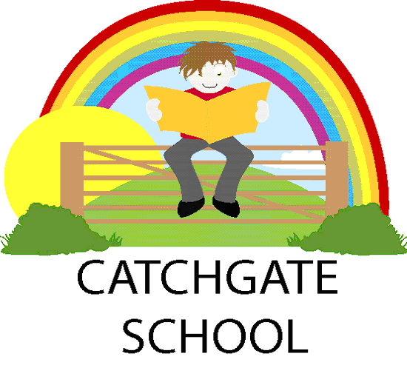
Catchgate Community Primary School
PERSON SPECIFICATION – CATERING MANAGER
Grade 4 SCP 5-8 £19,312 - £20,493 pro rata

 | Essential | Desirable | Method of assessment
Qualifications | - Food safety certificate  - Food hygiene certificate  - CGSE / L2 or equivalent in Maths and English  - Knowledge of food hygiene standards | - Catering qualification  - First aid certificate  - Knowledge of School food standards | - Application form  - Certificates  - Interview
Experience and Knowledge | - Catering / food production experience working in a kitchen environment  - Experience of ordering and managing stock  - Line management or team leading experience  - Knowledge of legislative requirements relating to the catering industry  - Knowledge of H&S Legislation and COSHH | - Leadership qualification  - Experience of working in a school | - Application form  - Interview  - References
Skills and competencies | - Excellent communication skills, verbal and written  - Technical knowledge of food and menu preparation  - Good IT skills  - Ability to manage multiple tasks and prioritise workload to meet service times  - Foster and maintain positive relationships with pupils and staff  - Build and maintain relationships with suppliers  - Work in partnership with the Local Authority School’s Catering Team  - Commitment to safeguarding and welfare of all pupils | - Safeguarding qualification / in date training | - Application form  - Interview  - References
Personal  qualities | - Friendly and approachable  - Excellent organisational skills  - Good team player  - Reliable  - Patient  - Diplomatic  - Flexible  - Creative  - Resilient  - Ability to seek advice, willingness to respond to school needs and request from senior leaders  - High expectation of self and team members |  | - Application form  - Interview  - References

