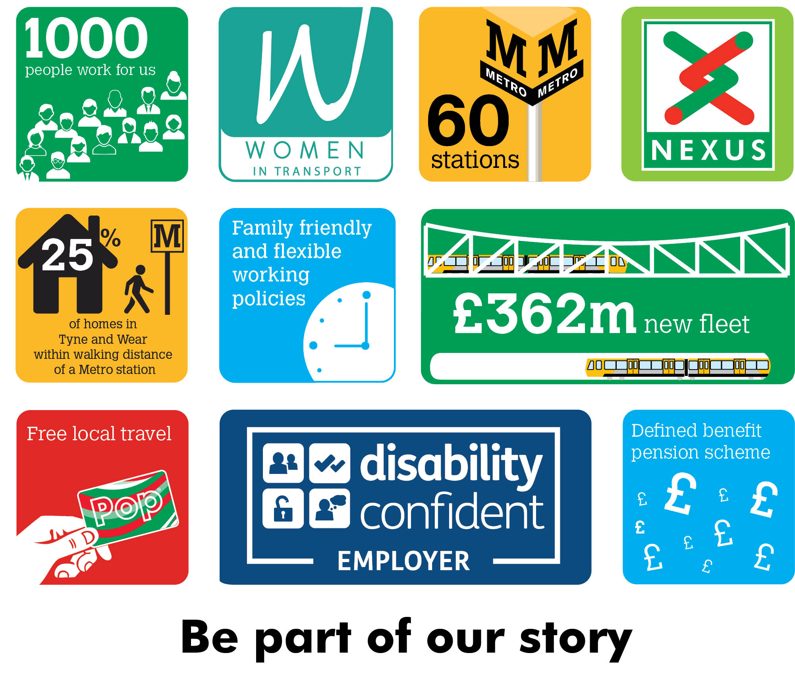
Infrastructure Safety and Assurance Manager
Nexus is looking to appoint a forward-thinking and dynamic professional to lead the safety and assurance functions within our Tyne and Wear Metro Infrastructure directorate.
As a member of the senior team, you will be a strategic thinker and engaging leader, responsible for the development of a best-in-class safety culture that achieves Nexus’ goal of ‘Safety Without Compromise’: we are looking for someone who really does want to make a difference.
You will also be a practical and hands-on manager, leading the team responsible for providing functional expertise and guidance, overseeing the effective implementation of our company management systems (safety, quality, environment and competence) across the Infrastructure directorate, ensuring Nexus meets it statutory obligations and reflects industry best practice.

You will have a track record of working in complex, safety-critical environments, ideally within the transport and/or construction sectors, and will be looking for a similarly challenging role.
Salary £competitive
Plus defined benefit pension scheme, free local travel and access to other benefits.
Closing date 5 June 2022
Find out more at nexus.org.uk

