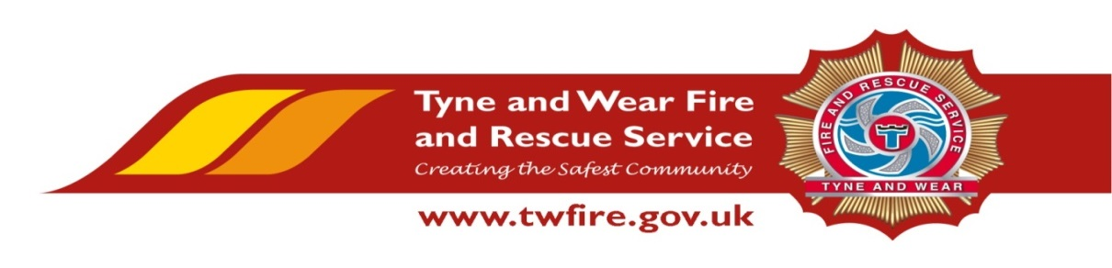

Cleaner – West Denton Community Fire Station
14 ¼ hours per week (Monday – Friday)
£5,590 per annum (£7.25 per hour) + Benefits

We have an opportunity for an experienced Cleaner to join our Cleaning Services Team. If you feel you are the right person for this role we would love to hear from you.
The Role

To undertake individually or as part of a team, the thorough cleaning of designated offices and associated accommodation to ensure that they are kept in a clean and hygienic condition.
Required Skills/Experience:

- Previous experience of cleaning within a professional environment
- Awareness of Health & Safety relating to Control of Substances Hazardous to Health (COSHH)
- Work unsupervised, on own initiative and as part of a team
- Ability to communicate effectively

What we can offer you

West Denton Community Fire Station is based at West Denton Way, West Denton, Newcastle upon Tyne with free parking and easy access from the A69. On site facilities include an onsite gym. The role also benefits from an attractive benefits package, including up to 38 days holiday, Local Government Pension scheme, and access to a range of social and volunteering opportunities.

Closing Date: Friday 9 December 2016 at 12 noon.

Interviews for this position will take place on Monday 19 December 2016.
Please visit https://www.northeastjobs.org.uk to apply for this role.
